# Terraform Notes

**Contents**

Installation Procedure: 3

Terraform Basics: 3

HashiCorp Language (HCL) BASICS: 3

Terraform workflow: 4

Update and destroy infrastructure using Terraform: 7

Terraform providers: 9

Configuration Directory: 10

Multiple providers and resources: 11

Using Input Variables: 12

Understanding the Variable Block: 13

Using Variables in Terraform: 16

Resource attribute: 18

Resource Dependencies: 20

Output variables: 21

Terraform state: 22

Introduction to Terraform State 22

Importance of state file: 23

Terraform State Considerations: 24

Terraform operations: 25

Some additional Terraform commands: 25

Mutable vs Immutable Infrastructure: 28

LifeCycle Rules: 29

Summary of lifecycle rules: 31

Datasources: 31

Meta arguments: 32

Version constraints: 36

Link for terraform kubernetes doc: 38

Link for terraform helm doc: 38

Terraform with AWS: 38

Programmatic access: 41

AWS IAM with terraform: 44

S3 with tearrfrom: 47

Dynamodb in terraform: 51

AWS EC2 Basics: 53

Terraform Procedure to deploy EC2 instance: 55

Remote state: 58

Remote state and state locking: 58

Procedure to configure remote backend with s3: 59

Terraform state commands to modify stae file: 61

Terraform Provisioners: 64

Remote exec provisioner: 64

local exec provisioner: 65

Terraform script to create EC2 instance: 67

Considerations with Provisioners: 68

Terraform Import, Tainting Resources and Debugging 68

Terraform Taint: 68

Debugging in terraform: 69

Terraform import: 71

Terraform modules: 72

Terraform module definition: 72

Creating and using modules: 74

Using modules from registry: 75

Terraform Functions and Conditional Expressions 77

Terraform functions: 77

Some Functions types of tearrform: 77

Terraform operators and conditional expressions: 80

Terraform Workspace: 82

How to use workspace: 83

## Benefits of Infrastructure as Code (IaC)

Before diving into Terraform and its functionalities, let's understand the concept of Infrastructure as Code (IaC) and its benefits.

### What is Infrastructure as Code?

Infrastructure as Code is a key DevOps practice that involves managing and provisioning computing infrastructure through machine-readable definition files, rather than physical hardware configuration or interactive configuration tools.

### Benefits of IaC

1. **Automation:** Automates the deployment of infrastructure, reducing manual processes and the potential for human errors.
2. **Consistency:** Ensures consistent environments are created every time, eliminating the "it works on my machine" problem.
3. **Version Control:** Infrastructure can be version-controlled, allowing for easy tracking of changes, rollbacks, and collaboration among teams.
4. **Cost Savings:** Reduces the time and resources required to manage infrastructure, leading to cost savings.

## What is Terraform?

Terraform is an open-source infrastructure as code (IaC) tool developed by HashiCorp that allows users to define and provision infrastructure using a high-level configuration language.

It is particularly powerful in managing cloud services and infrastructure, with Amazon Web Services (AWS) being one of the most popular cloud platforms supported by Terraform.

This document aims to introduce the basic concepts of Terraform, its benefits, workflow, and how it can be used to manage AWS services effectively.

## Installation Procedure of terraform:

$wget https://releases.hashicorp.com/terraform/0.13.0/terraform_0.13.0_linux_amd64.zip

$ unzip terraform_0.13.0_linux_amd64.zip

$ mv terraform /usr/local/bin

$ terraform version

Terraform v0.13.0

## Terraform Basics:

* It uses configuration file with extension .tf to deploy infrastructure files which are written in HCL (Hashi Corp Language).
* Resource is object data for managers. E.g. file on local host or VM on cloud such as EC2 instance.
* Hundreds of resources of cloud and on premises infra can be provisioned using terraform.

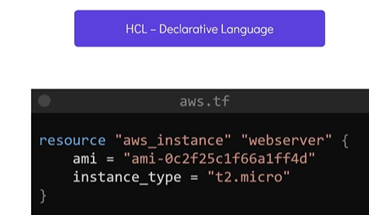

### HashiCorp Language (HCL) BASICS:

#### Syntax:

* HCL file consist of blocks and arguments.
* Block is defined within curly braces and it contains as set of arguments in key-value pair format representing the configuration data.
* Block contains information about the infrastructure platform and set of resources within that platform we want to create.

E.g. suppose user wants to create file.

* The block type used is resource block and it is identified using keyword “Resource”.

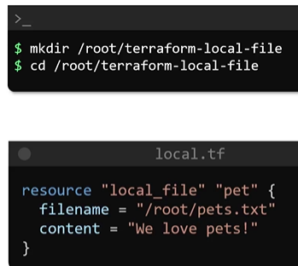

* Resource type is fixed value. It is combination of provider name and type of resource.
* Need to name resource block ahead of its type. This is logical name used to identify the resource.
* Inside resource block we mentioned resource details or block arguments in key value format. In our e.g. key-value pairs are:

filename = “/root_file.txt.”

contents = “We love pets!”

* Arguments are specific to resource that user want to create.

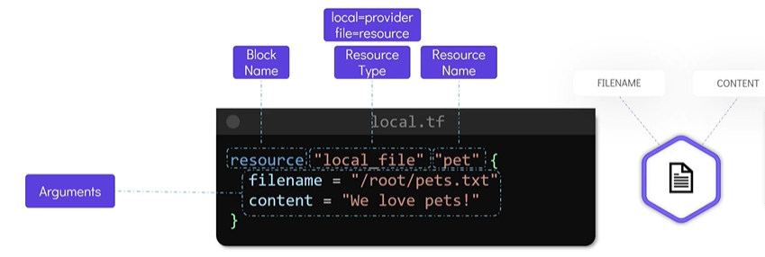

### Basics of HCL

* **Resources:** The primary construct in an HCL file, resources represent a piece of infrastructure, such as an EC2 instance or an S3 bucket.
* **Providers:** Specify the cloud service (e.g., AWS) and provide necessary credentials.
* **Variables:** Allow customization of Terraform configurations without altering the main configuration.

variable "instance_type" {

description = "EC2 instance type"

**default** = "t2.micro"

}

resource "aws_instance" "my_instance" {

ami = "ami-01b799c439fd5516a"

instance_type = **var**.instance_type

}

### Structure of a Terraform Configuration File

A Terraform configuration file typically includes:

* **Provider Configuration:** Specifies the cloud provider and credentials
* **Resource Definitions:** Define the infrastructure components
* **Variables:** Optional variables to customize the configuration
* **Outputs:** Specify output values that can be useful for other configurations or providing information to the user

### Terraform workflow:

* It consist of four steps:
* Write a configuration file.

#### terraform init:

* It will check configuration file and initialize working directory containing .TF file.
* This command makes use of provider (in our case local). Provider details identified using resource type declared in the resource block.
* Then it will down load plugin in to be able to work on the resource declared in the .TF file.

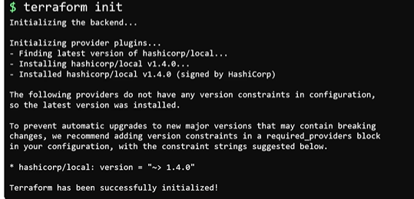

#### terraform plan:

* command to review the execution.
* This command will show actions that will be carried out by terraform to create resource.
* The output has + symbol next to local_file type resource in our e.g. pet.

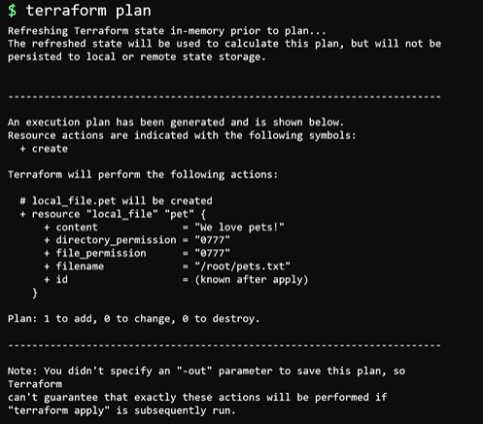

* It displays all the arguments that we specified in the .TF file for creating the resource.
* Some additional arguments will also be displayed.
* + symbol indicates resource will be created.
* Resource is not created yet but this command is provide information to review and ensure all the actions to be performed in execution plan is desired.

terraform apply:

* Command is used to apply changes.
* This will display execution plan once again and ask for confirmation.
* After typing Yes it will actually create

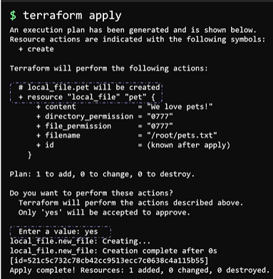

#### terraform show:

* Used inspect the state and displays resource details that is created.

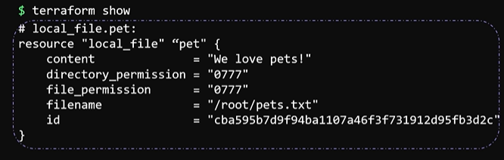

* Terraform documentation provides all the required details of provider and resources supported.

https://registry.terraform.io/providers/hashicorp/local/latest/docs

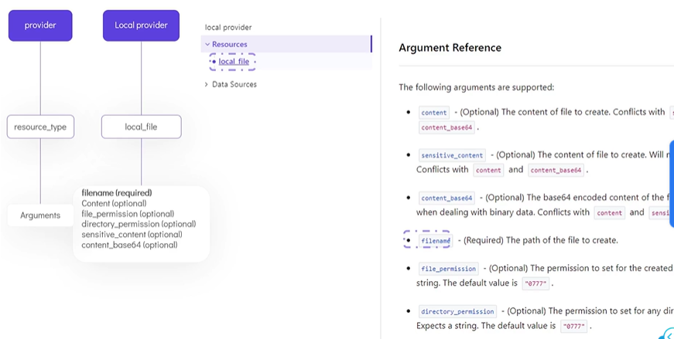

### Update and destroy infrastructure using Terraform:

* Make required changes in .TF resources definition file.
* If you use terraform apply command Now it will show -/+. It implies that resource will be deleted and recreated.
* Lines with comment “force replacement” is responsible for the deletion and recreation.
* Terraform will delete file and recreate file with new permissions.
* If you want to go ahead use terraform apply command and type yes when prompted.
* This type of infrastructure is called immutable infrastructure.

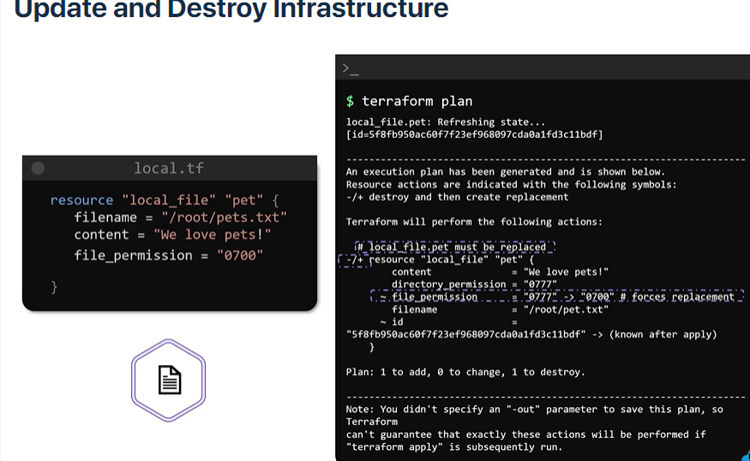

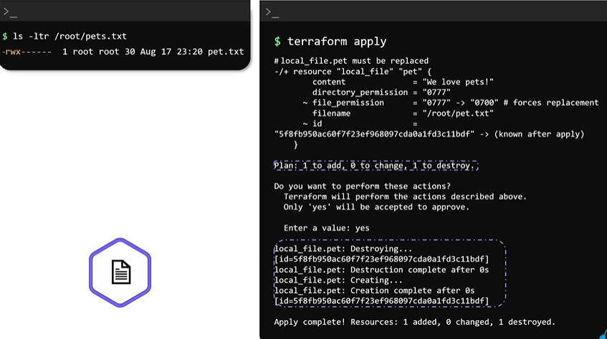

#### Terraform destroy:

* Used to delete infrastructure completely.
* It will display execution plan, all its resource with - symbol.
* - symbol implies that resource will be deleted.
* To go ahead type yes when prompted.
* This will delete all resources in the current configuration file.

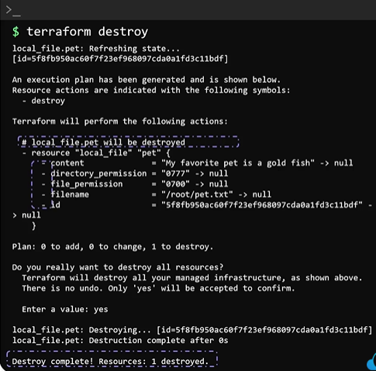

* If resource type is local_sensitive_file then file contents will not be displayed on use of terraform commands.

### Terraform providers:

* When we initialized terraform in directory (containing .tf file) with terraform init command terraform will download and installs plugins for the provider used in configuration file.
* Terraform uses plugin based architecture to work with 100s of infrastructure platforms such as AWS, GCP, AZURE or Local.

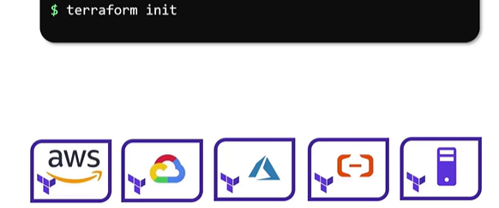

* During execution of terraform init command plugins are downloaded in hidden directory named .terraform/plugins inside working directory having .tf configuration file.
* Plugin name mentioned in the output of terraform init command is also called as source address. This is identifier used to download plugin from registry.
* The first part of the name is organizational namespace e.g. hashicorp followed by type.

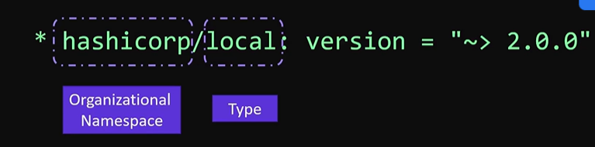

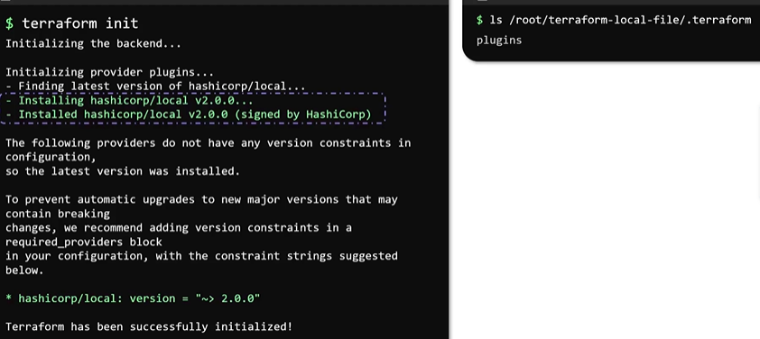

* Plugin name optionally have one more filed called hostname. It is the name of registry where plugin is located.
* Default hostname is registry.terrform.io

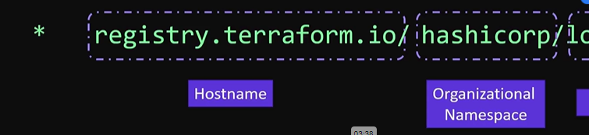

* Default terraform installs latest versions of providers as they supports newer functionalities added, bug fixes.
* Configuration files can download specific version of provider.

#### Types of providers:

There are three types of providers:

#### Official provider:

These providers are owned and maintained by HashiCorp. E.g. AWS, GCP, AZURE

#### Partner Provider:

A partner provider is owned and maintained by third-party Technology Company that is partnered with HashiCorp. E.g. Heroku, Digital Ocean etc.

#### Community provider:

* Published and Maintained by individual contributors of HashiCorp community.

### Configuration Directory:

* Configuration directory may have multiple configuration files with extension .tf.
* Terraform will consider all files with .tf extension within configuration directory.
* Another common practice is to define multiple configuration blocks within a single file.

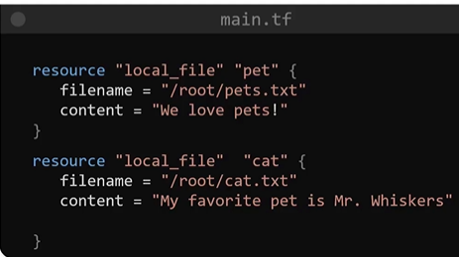

* As per common naming convention file is named with main.tf.
* Many other configuration files can be crated listed below based on requirement.

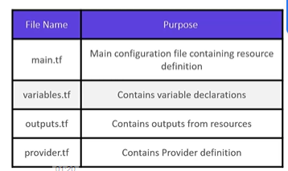

### Multiple providers and resources:

* One can define multiple resources from different providers in single file.

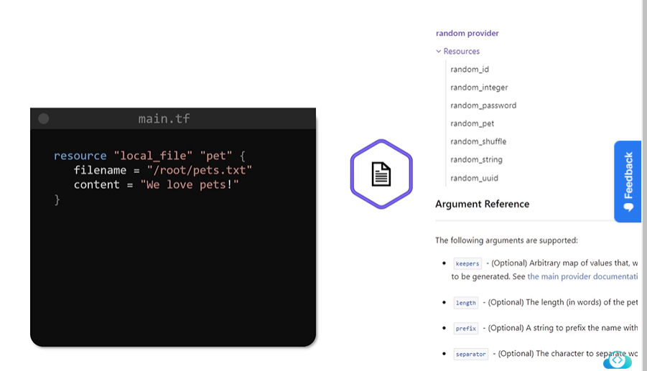

* In our example we will use resource random pet from random provider.

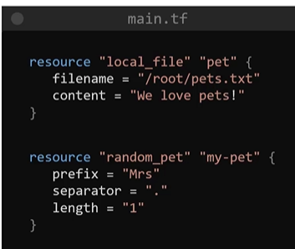

* This file will generate two resources local file and random pet name (with id as identifier.)

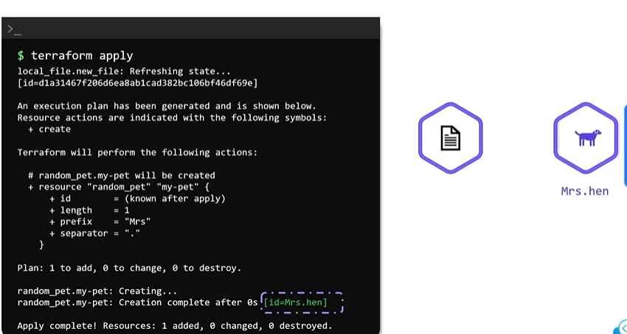

Alias: We can use same provider with different requirements for different resources of same type using alias as follows.

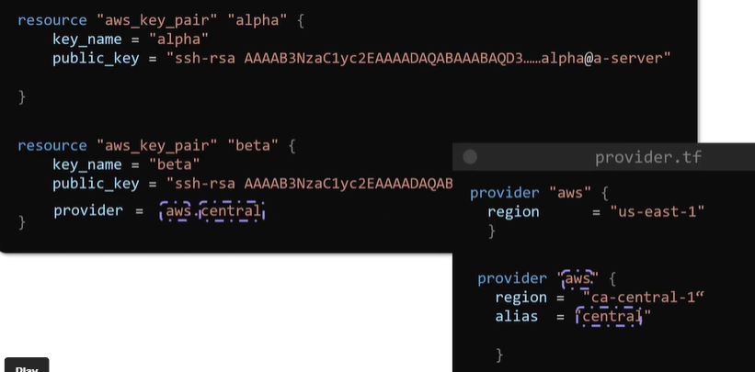

### Using Input Variables:

* So far we have defined arguments as directly in configuration file inside resource block. This method is called hard code definition.
* It has limitations on:
  + Reusability of code

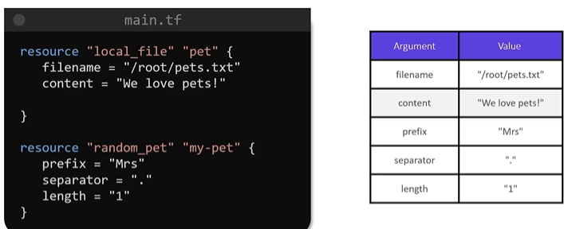

* To overcome above limitation input variables are used.
* To assign input variable another file called variables.tf is used.
* It consist of block of arguments with keyword variable followed by variable name.
* Generally argument name is used as variable name.
* Within the block default value can be passed which is optional.
* To pass this values in main configuration file we need to replace argument name with variable names prefixed with var.
* We can make changes of existing arguments by changing values of variables in variable.tf file.

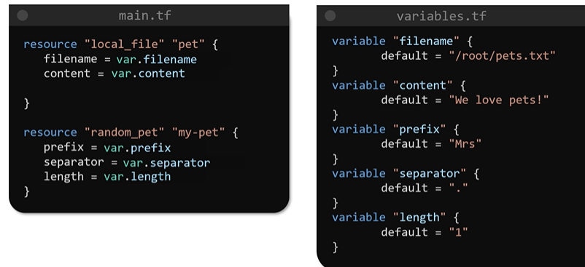

### Understanding the Variable Block:

* It accepts three parameters
* default: It is optional parameter used to specify default value of variable.
* type: It is optional parameter used to specify type of variable. If type is not mentioned it is set to type any by default.

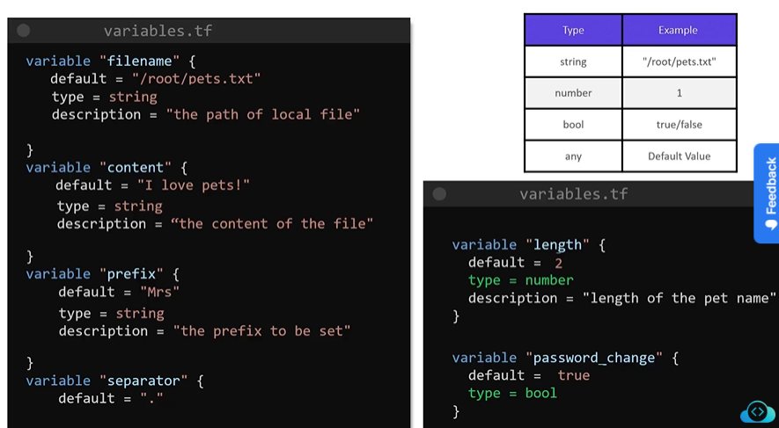

Few more type of variables are as follows:

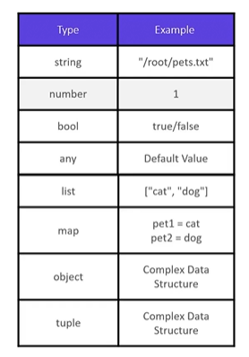

* list: it a numbered collection of values and can be accessed using index.

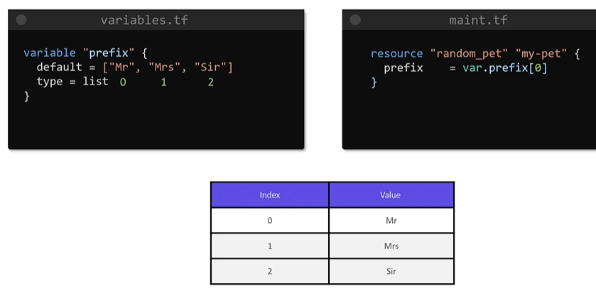

* map: data is represented in the format of key-value pair enclosed within curly braces.

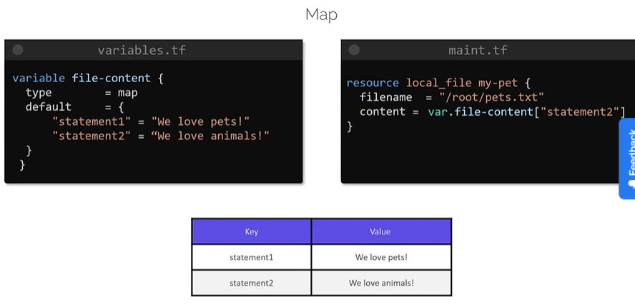

* One can combine type constraints. E.g. list of string type elements.

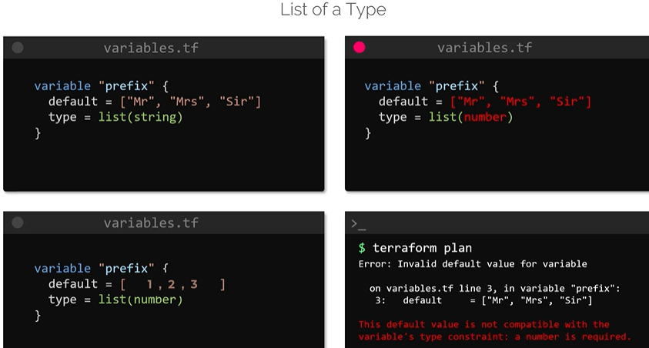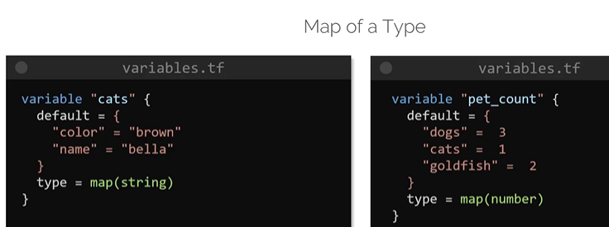

* set: it is similar to list but do not have duplicate elements.

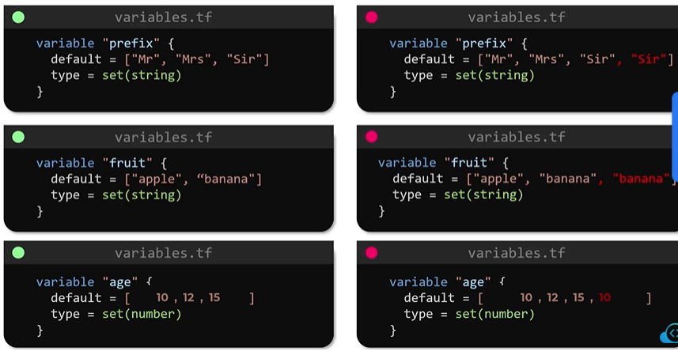

* objects: With objects we can create data structures by combining all variable types.

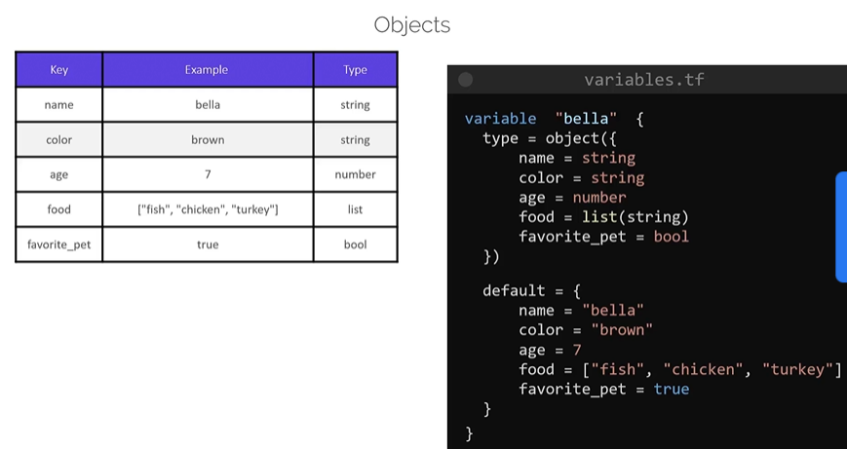

* tuples: tuple is similar to list but consist of sequence of elements. The difference is list uses similar type of elements where as in tuple we can use elements of different type.
* Type of variables used in tuple is defined inside square bracket.

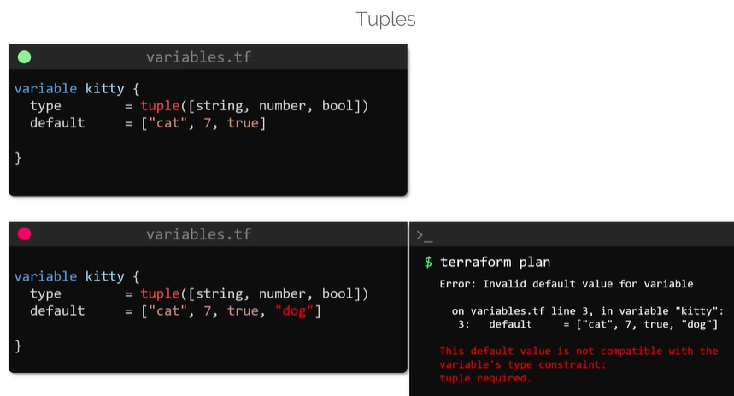

### Using Variables in Terraform:

* If default values are not mentioned inside variable block terraform will prompt to enter value for each such variable during resource creation.

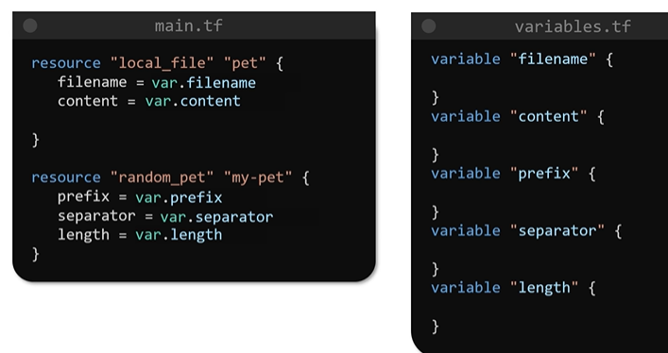

* Input to variables can be feed using command line as follows.



* We can use environment variables with prefix TF_VAR followed by argument name.

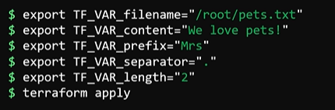

* Using variable definition files having extension .tfvars we can feed variable values to configuration file.

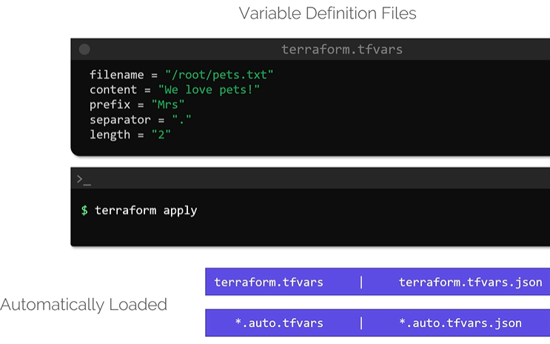

* If you use any other filename then -var-file flag is used as follows.

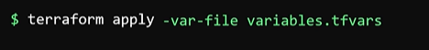

* Suppose single argument has multiple sources of values by various means as follows.

Then terraform follows variable definition precedence to decide final assignment.

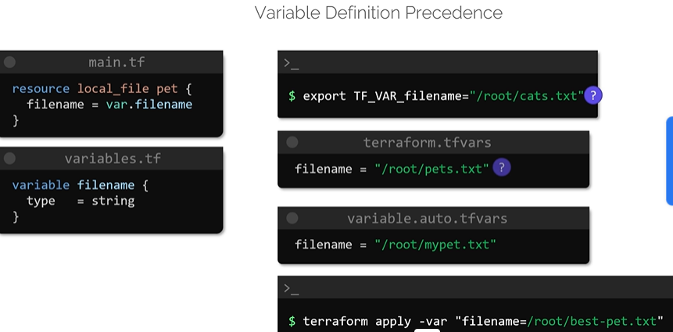

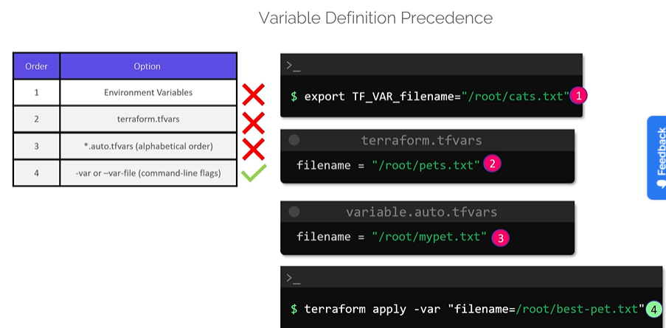

### Sensitive information:

Sensitive info such as passwords, API keys, logs etc is to be protected using sensitive keyword. This is achieved adding sensitive = true attribute to variable declaration as follows.

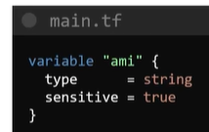

* Other ways are creating separate file for secrets or expose variables as environmental variable.
* If we try to display value of sensitive variables using output block then it will throw an error.
* But sensitive info is stored as text in state file so we need to secure state file.

### Resource attribute:

* One can link two resources using resource attributes.

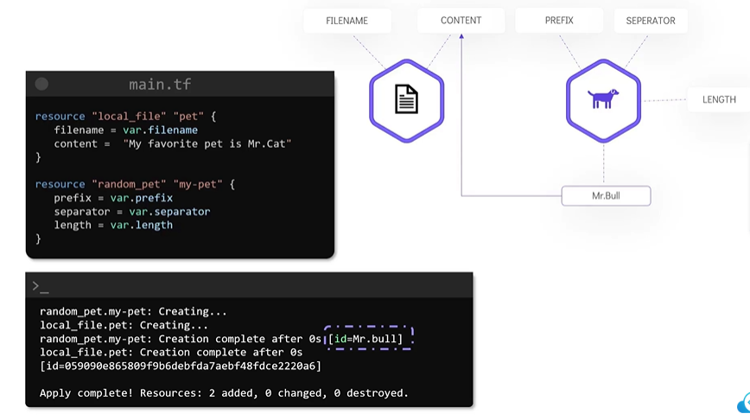

* Each resource has list of attributes that can be retuned during terraform apply command.
* To use return value from another source we have to use expression as follows in resource block.

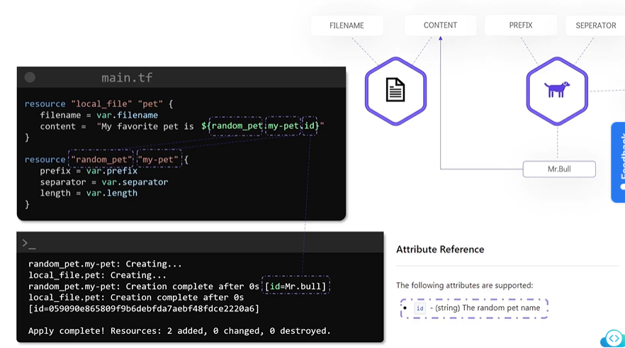

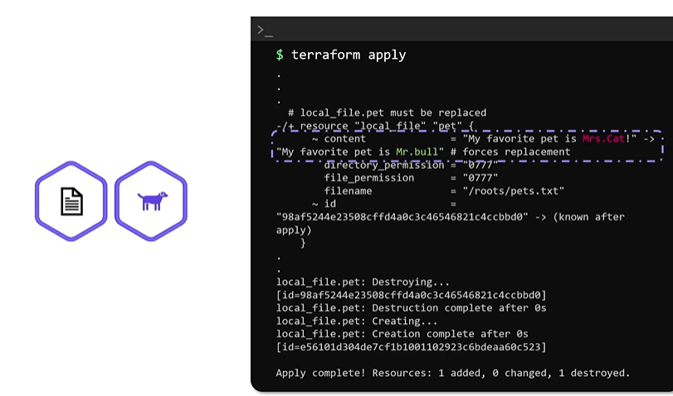

### Resource Dependencies:

* When terraform create resources it will know about all its dependencies
* Terraform creates resources in order based on dependencies.
* Terraform deletes resources in reverse order in which those are created.
* If user have not specified resource dependency and terraform figure out itself then it is called implicit dependency.
* But we can specify resource dependency in configuration file. It is called explicit dependency.
* It is required when one resource depends on other resource indirectly and do not use reference expression.
* It uses depends_on keyword as shown in following example.

local_file resource is created after random _pet resource.

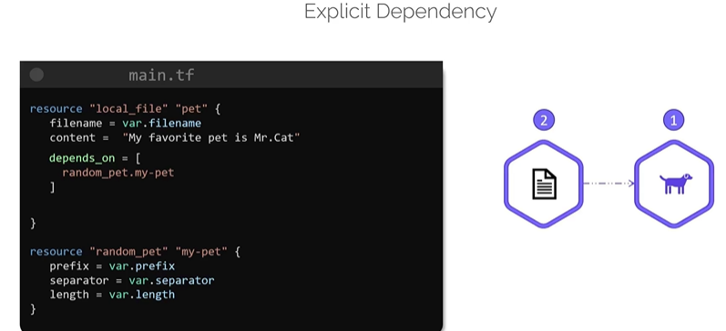

### Output variables:

* Similar to input variables we can define block for output block as shown below.
* Syntax used to create output block uses ouput keyword followed by variable name.
* It has mandatory argument called value which is reference expression.
* It also has option argument description.

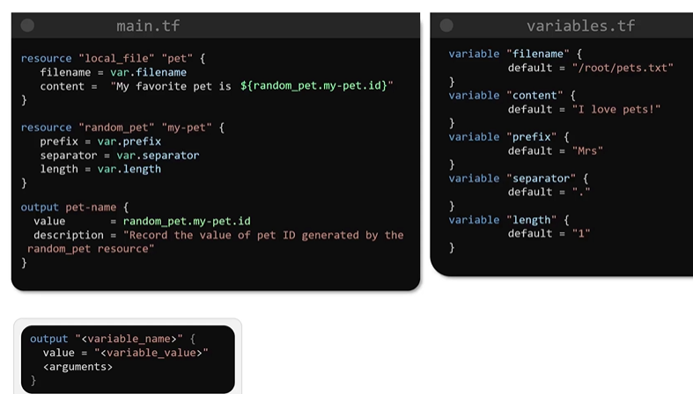

* With terraform apply command value of output variable is displayed.
* It is mainly is used to display values of variables on screen or to feed values to other IaC tools.

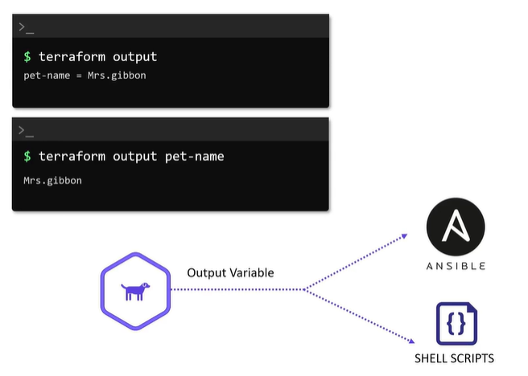

### Local values:

Suppose we want to use some values repeatedly in multiple resources e.g. common tags for all ec2 instances. Instead of writing definitions in each resource we can define it once using local block and use reference of that local block in our resources.

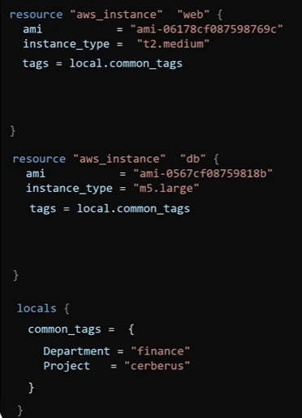

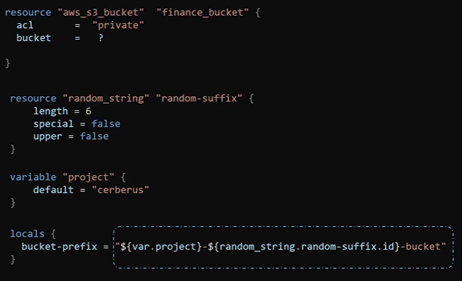

### Dynamic Block:

To avoid repetitive code such as ingress port definition for security group in AWS we can use dynamic block. Dynamic block starts with keywork dynamic and block name. Then we need to define content block for repeatable contents.

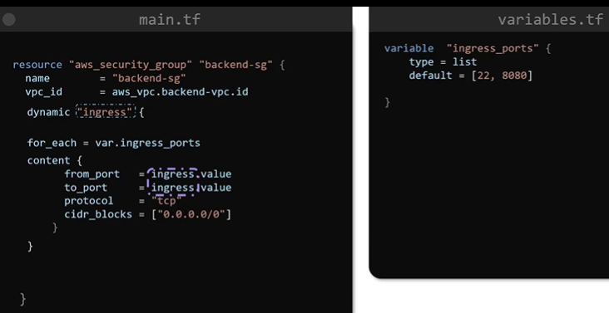

We can use define iterator to loop through inside dynamic block to avoid use of name of dynamic block.

Reference expression used in another block to iterate through dynamic block is called splat expression.

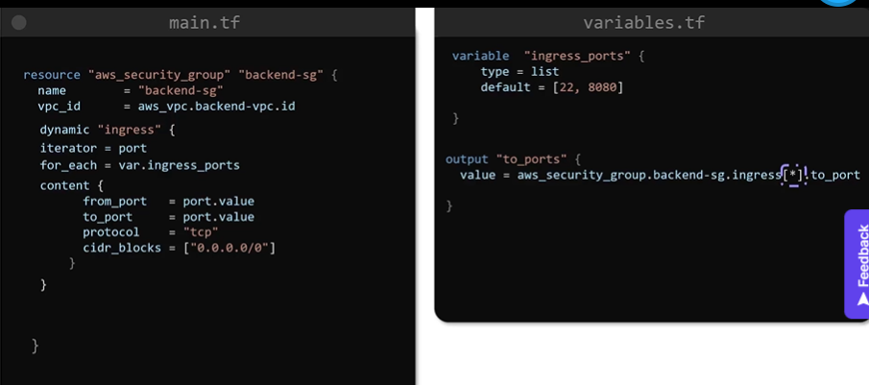

## Terraform state:

### Introduction to Terraform State

* When terraform init, plan commands executed first time there is no details about state in the o/p printed. This implies that there is no state as there are no resources provisioned.

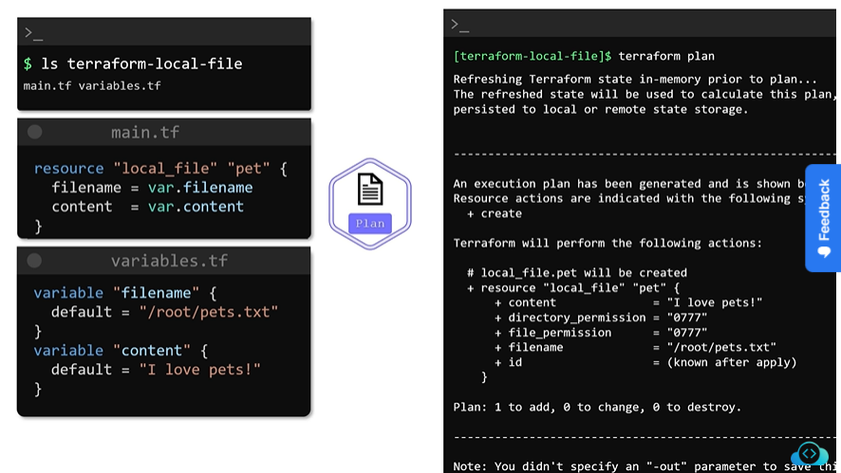

* On execution of terraform apply command terraform will refresh the current state and proceed to create execution plan.
* If any state exist corresponding terraform.tfstate file is present in configuration directory. This file is called as terraform state file.
* The state file is a JSON data structure that maps real world infra resources to the resource definition in the configuration files.
* Terraform plan and apply command uses this file as single source of truth.
* Both of these commands compare contents of state file and configuration file during execution.

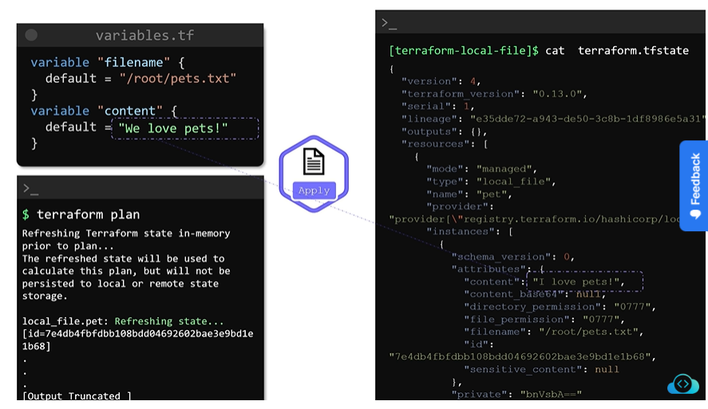

* After making changes in resources, terraform update state file so that there will not be any difference between state file and configuration file.

### Importance of state file:

* When terraform create resource it records its identity in the state.
* Each resource created have unique id to identify resources in the real world.

#### Tracking Metadata:

* State file also track metadata of resources such as dependencies.
* Based on dependency resources are created in sequential manner. Some resources which do not have dependencies are created at a time.
* During deletion or modification of resources dependency details are fetched form state file as configuration file is modified as per new requirement.

#### Performance:

* In real word scenario there are hundreds of resources. So for every plan and apply command it is not feasible to recompile details from actual resources. In such scenario state file is consider as single source of truth.
* Terraform stores cache of attribute values for all resources in state file.
* We can bypass refreshing terraform stare every time as follows.

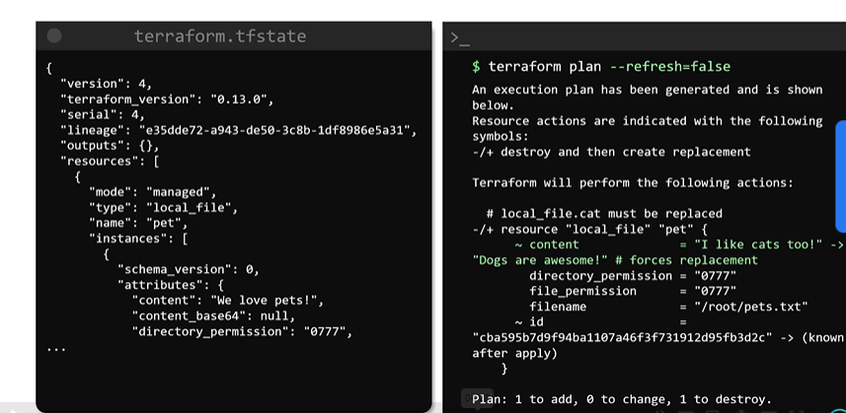

#### Collaboration:

* While working in a team each user must fetch latest state file and then run plan or apply command and no two users run terraform at same time.
* It is recommended to store state file in remote data store. This allows state file shared between all team members securely.

### Terraform State Considerations:

* State file contains sensitive information such as password, ip addresses etc.
* In terraform configuration file and state files are important files.
* It is recommended to store configuration file in distributed version control system such as Git.
* Whereas sate file to be saved inside remote backend data stores such as AWS S3, Azure Storage etc.
* Terraform state is for internal reference we should never manually edit the state file.
* If required then we should use terraform state commands to modify state file.

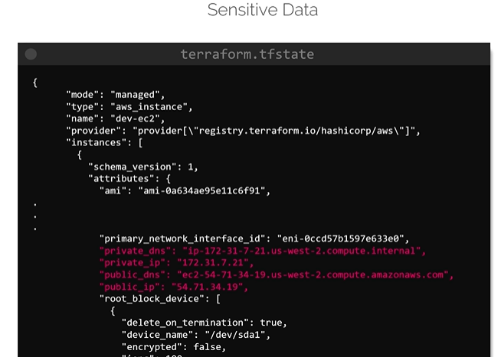

## Terraform operations:

### Some additional Terraform commands:

#### terraform validate:

* Used to check syntax of configuration file. If there is problem terraform will display error message.

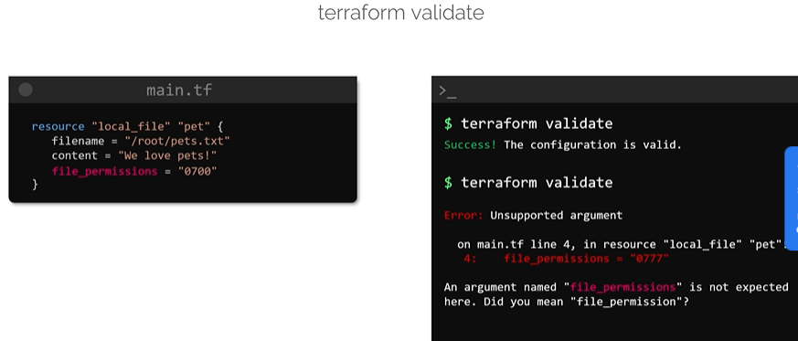

#### terraform fmt:

* Used to improve readability of configuration file. It reformat configuration file content into canonical form.

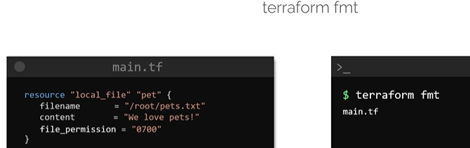

#### terraform show:

* Displays current state of resource along with its attribute and their values.

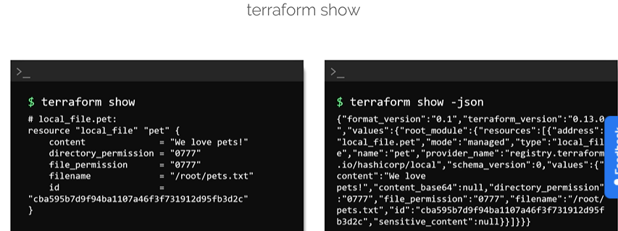

#### terraform providers:

* Used to list providers used in configuration directory to create resources.

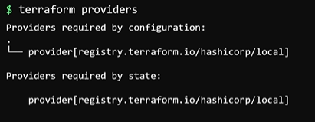

#### terraform providers mirror <destination)directory>:

* Used to copy provides of current configuration directory to new directory given in command.

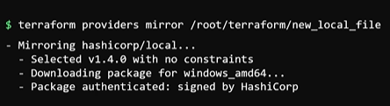

#### terraform output:

* used to display all output variables of configuration directory.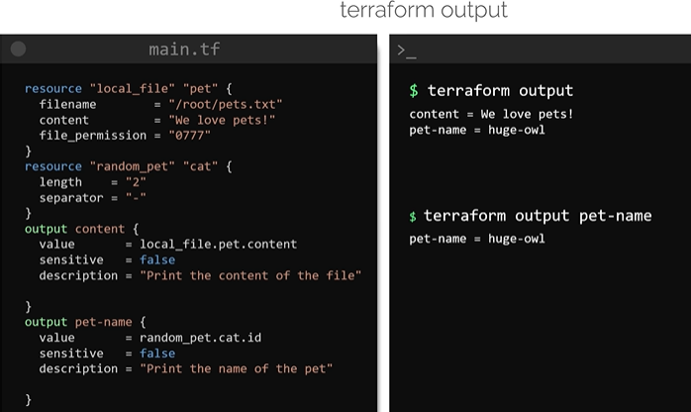

#### terraform refresh:

* Used to update state file as per actual resources.
* Sometimes resource are updated manually. To update those changes in state file refresh command is used.
* With terraform apply and plan command terraform refresh command is used to update state file prior to Terraform generating an execution plan.
* This can be bypassed with -refresh-false option with commands.

#### terraform graph:

* Used to create visual representation of the dependencies and a terraform configuration or execution plan.
* This command as soon as configuration file is ready. This command can be executed without initialization of configuration directory with terraform init command.
* Output of this command is graph in dot format can difficult to visualize. To make visualization simpler we can pass this output to visualization tool such as Graphviz.

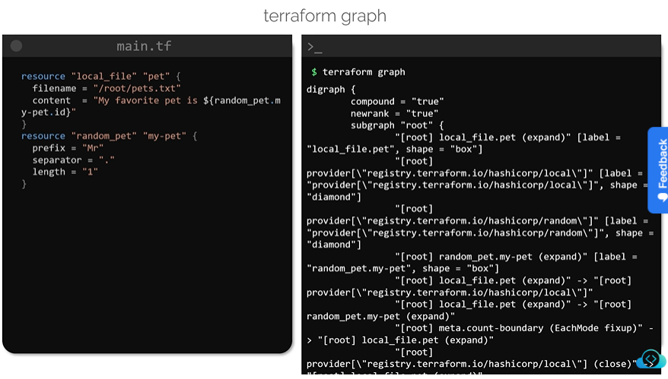

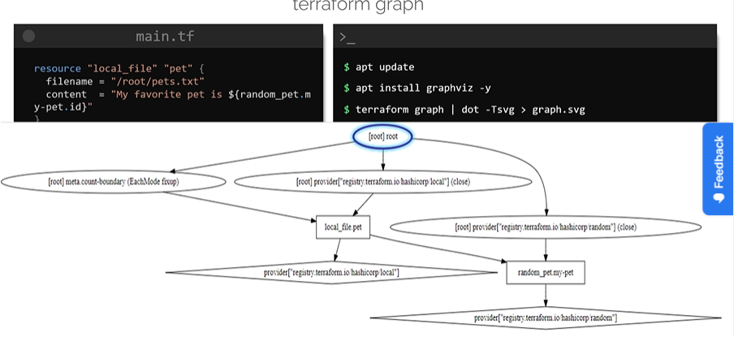

### Mutable vs Immutable Infrastructure:

* Suppose we have pool of servers and want to upgrade all servers to some desired version.
* If we update the server one by one this type of upgradation is called in-place upgradation.

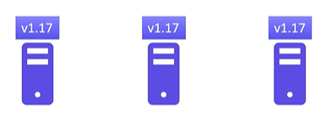

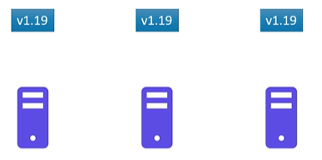

* For some of servers upgrade activity failed and they remained on older version.
* This is called configuration drift which may lead to inconsistent performance.

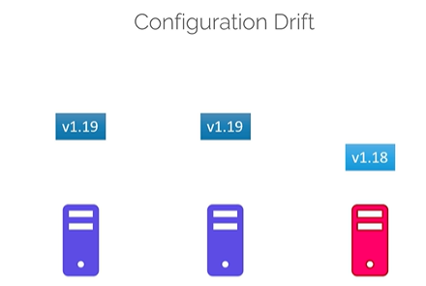

* Instead of experimenting on live servers we can add one by one redundant server of required version and delete the one by one servers of old version.

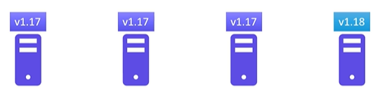Such type of infrastructure is called immutable infrastructure. So in case of immutable infrastructure we can’t carry out in-place update. In case of failure we make old server intact.

* Immutability makes it easier to version the infrastructure and to roll-back or roll-forward between versions.
* Terraform follows similar approach to create a new resource. To creates new resource it will delete old and then create new resource.
* This sequence can be altered or resource deletion can be avoided by using lifecycle rules.

### LifeCycle Rules:

* We can mention lifecycle rule in the resource bock to alter the routine sequence of deletion and then creation of resource as follows.

#### create_before_destroy:

* This rule ensures that when there is change in configuration identified then new resource is created first before deletion of old resource.
* Recommended to use this rule for logical resources. If you use this rule for resource like file which should be unique at given location then it will behave abnormally.

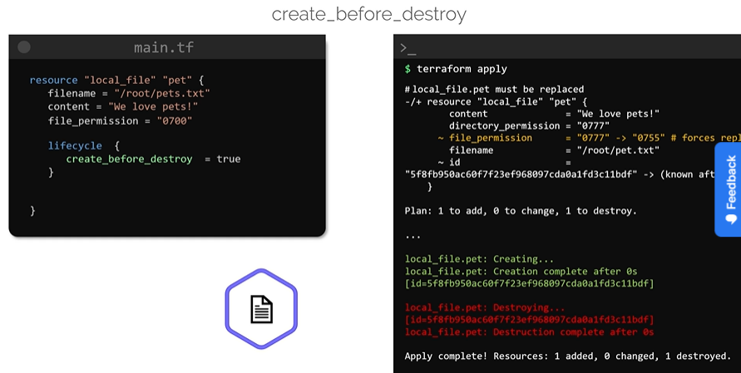

#### prevent_destroy:

* This will retail old resource if there is change in configuration and display error message.
* This is used in case of database resources such as mysql to prevent from accidental deletion during configuration update.
* This wiil not pervert resource if tried t delete it with terraform destroy command.

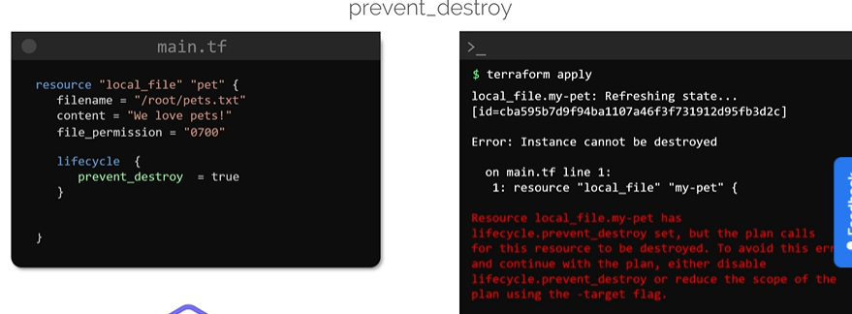

#### ignore_changes:

* This prevents to update resources based on list of attributes provided.
* It accepts list of attributes in side square brackets as shown.

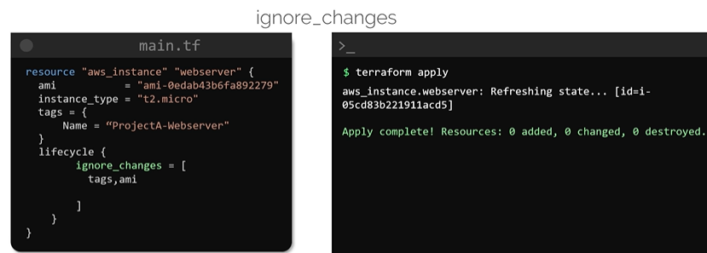

* If all keyword is used inside square bracket of list it will prevent resource in case of any of attributes modified.

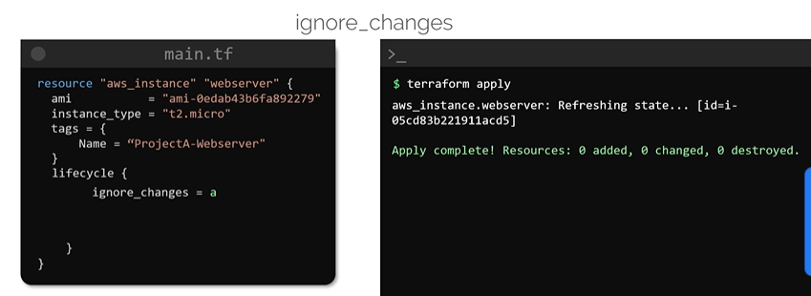

### Summary of lifecycle rules:

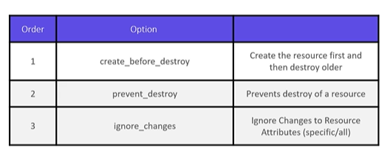

### Datasources:

* Datasources are used to read data from sources which are outside the control and management of terraform such as resources created by other IaC tools, shell scripts.
* Data block is similar to resource block. This type of block starts with keyword data.
* Datasource block consist of specific arguments for data source and to know which argument is expected we can refer the provider documentation in terraform registry.
* Data read from datasource is available in “data object” in Terraform.

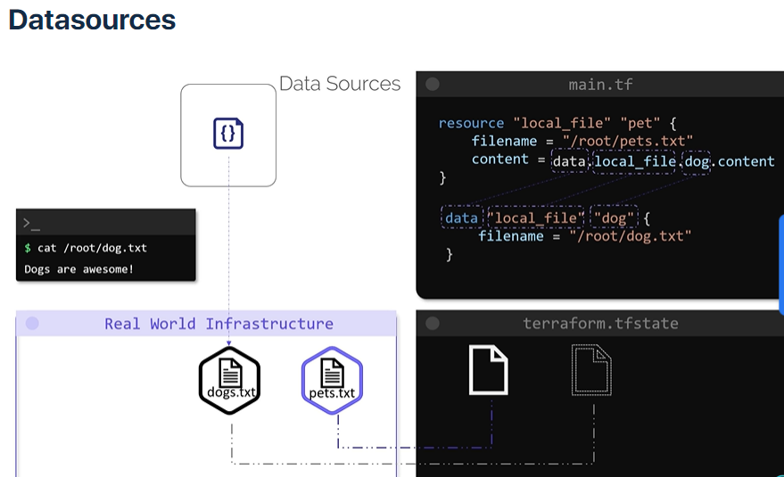

* Terraform Documentation provides information about attributes that can be exported under heading of Data sources.

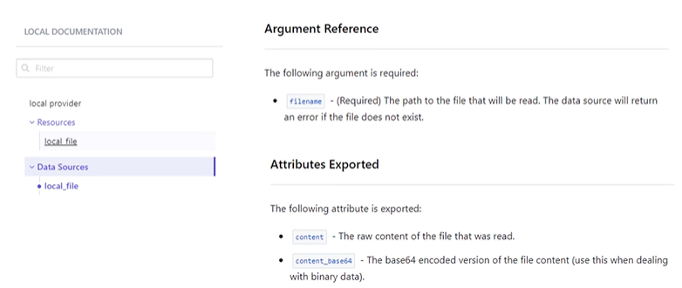

#### Difference between resource and datasources:

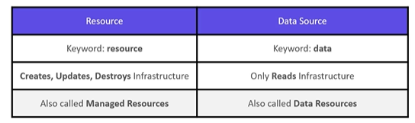

### Meta arguments:

* Multiple resources of same type can be created using meta-arguments of loop type in terraform.
* Meta-arguments can be used within resource block to change the behaviour of resources. E.g. depends_on, lifecycle (lifecycle rules).

#### count:

* count meta-argument is used to create multiple instances of resource.
* We have to provide list of arguments in variable file to create corresponding multiple resources.
* We have to use count.index in configuration file to access list contents by using reference of count value.

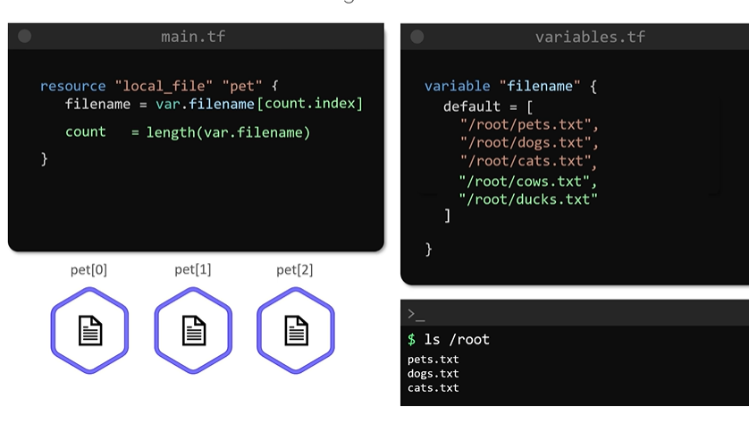

* We assign value of length of list to count by using inbuilt function length().

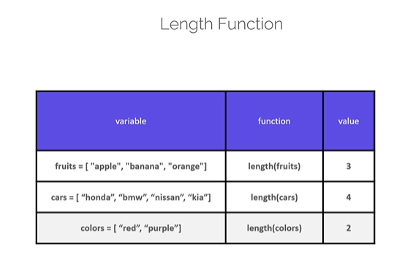

* Suppose we want to remove first file but don’t want to unchanged other files. If we remove fist argument of list and used count method. It will destroy all files and recreate second and third file. So this does not fulfil our requirement.

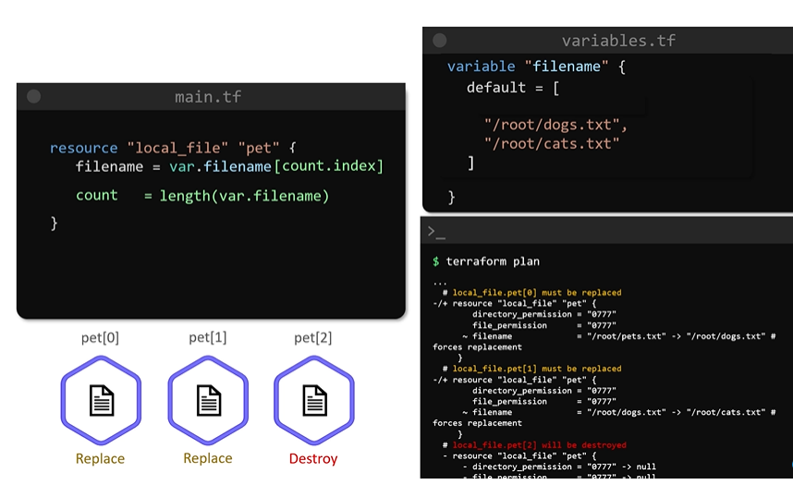

* This happens because when resources are created they are part of list.

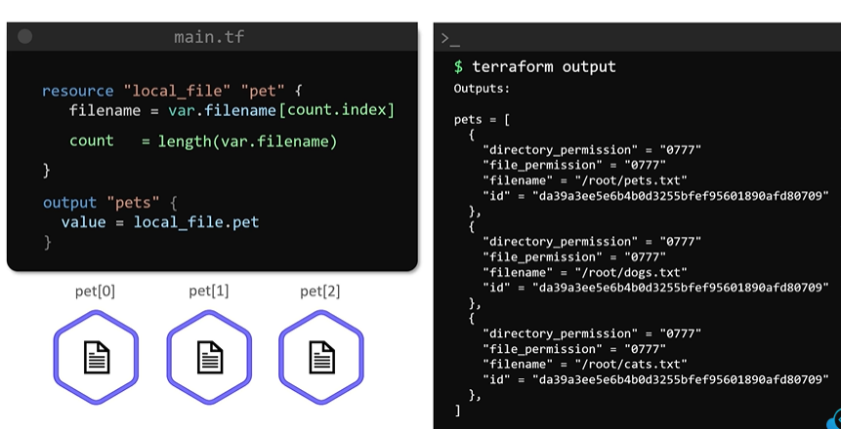

* When we remove first element from resource list other elements are still part of list but their index values changes.
* Hence rest of two resources gets deleted and recreated with new index values.

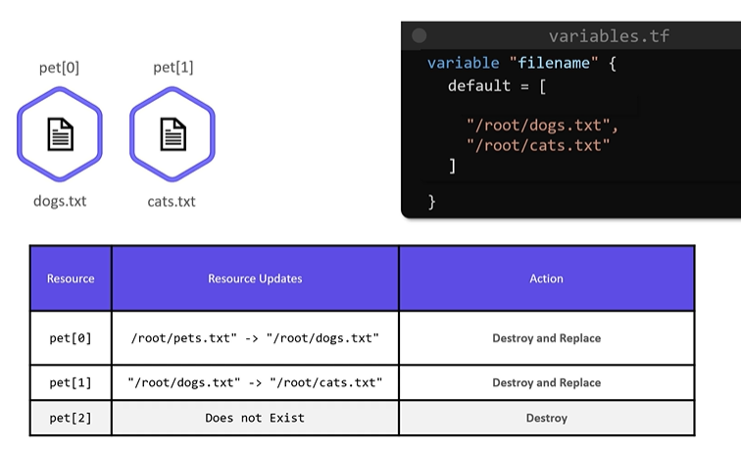

#### for-each:

* To overcome above drawback for-each loop is used.
* For-each loop make use of set of strings type arguments. Set is similar to list but does not allow duplicate values.
* Another way is use variable type list of argument in variable file and use inbuilt function toset() (which converts list into set) in configuration file.

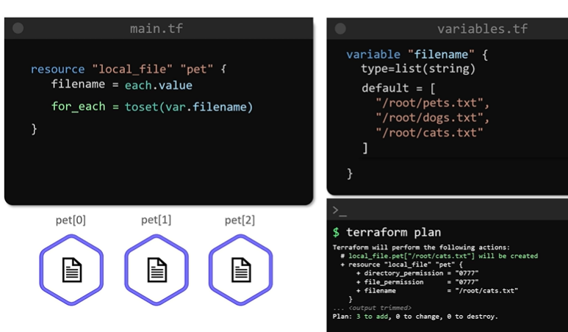

* If we remove on element of set from variable.tf file. It will remove first resource. Rest of two resources remains unchanged.

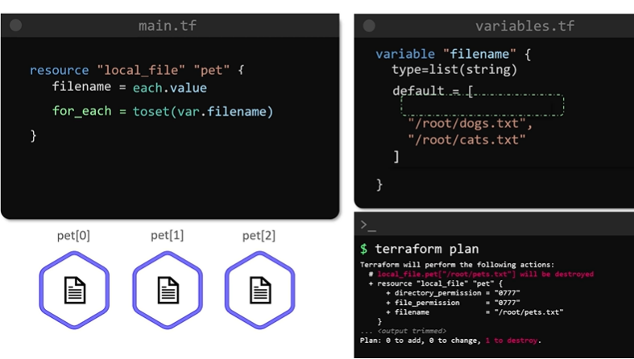

* In above ways resources are stored as elements of map and keys of map are elements of list or set in variable.tf. Hence on deletion of any of resource other resources remains unchanged.

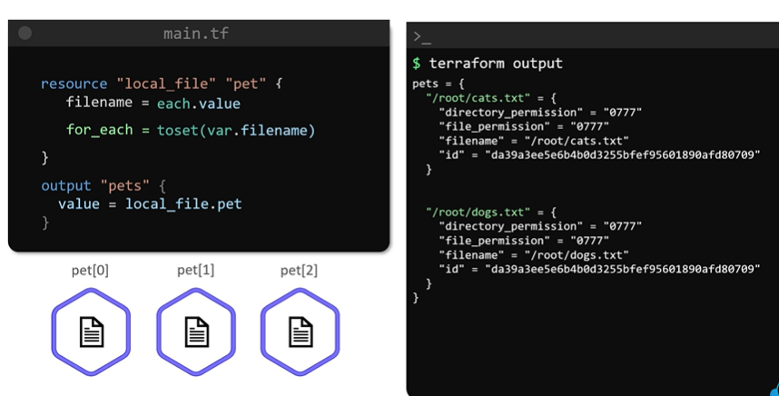

#### Output of count and for-each methods:

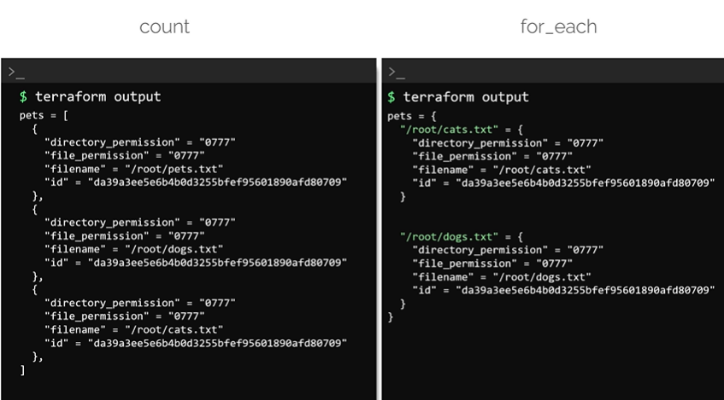

### Version constraints:

* Without any additional version details terraform init will download latest version of providers.
* But behaviour of resources varies version to version. Hence to get providers of required version we need to feed versions details.
* We can make sure that specific required version of provider will be used by terraform.
* Instruction to use specific version of provider is available in the provider documentation in the registry.
* Navigate to get required instruction on documentation and copy those instruction in configuration file.

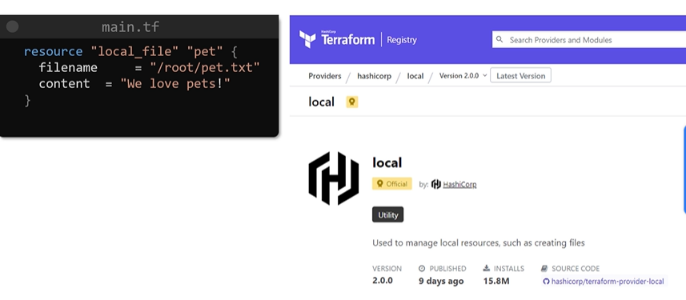

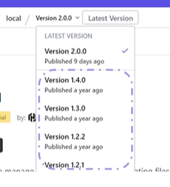

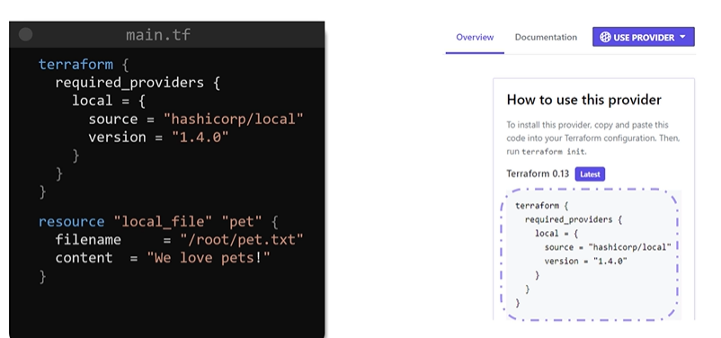

* We can feed expressions to get one of desired available versions as follows.
* To avoid use of specific version

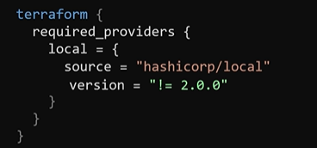

Comparison operators can be combined in an expression to define range of versions. Terraform will **use latest available version from given range.**

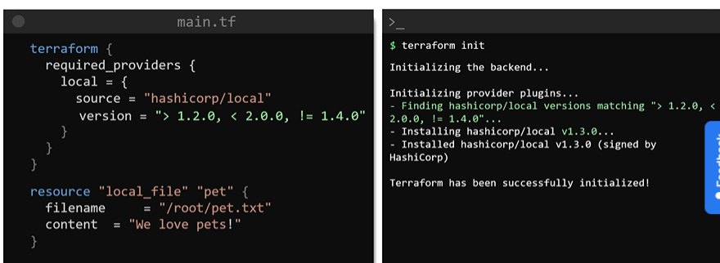

* We can make use of pessimistic constraint operator. This allows terraform to download the specific version or any available incremental version based on the value we provided.

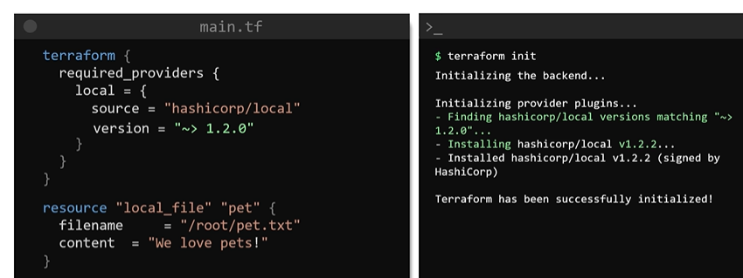

### Link for terraform kubernetes doc:

<https://registry.terraform.io/providers/hashicorp/kubernetes/latest/docs>

### Link for terraform helm doc:

<https://registry.terraform.io/providers/hashicorp/helm/latest/docs>

## Terraform with AWS:

* Root user has administrator privileges in AWS. So it should not be used frequently.
* Instead we should create more users and restrict their access in AWS as per their scope of work.
* To do this we use IAM service of AWS.
* There are two type of access mechanism
  + Access to Management Console - user should have username and password
  + Programmatic Access - User uses command line interface and requires Access Key Id and Secrete Access Key.

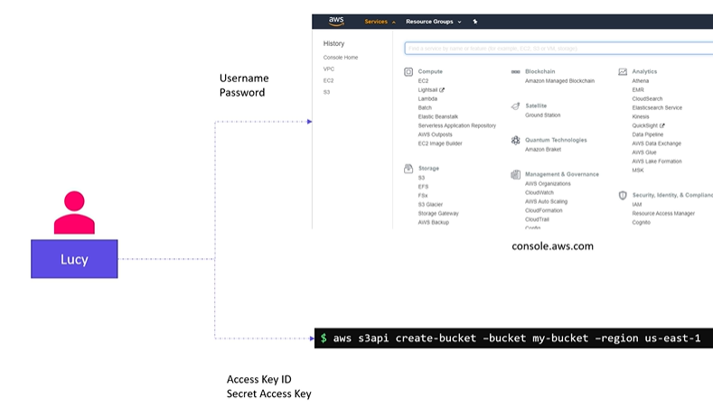

* What users can do and can’t do is decided by AWS policy during user creation. There are several built in policies defined and managed by AWS. These are mainly categorized as follows.

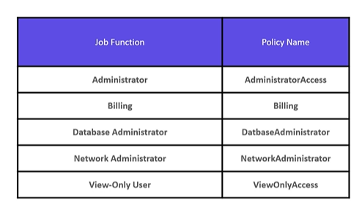

* IAM group is collection of users and policies can be attached to it. Each user of group bound to policies attached group.
* If you want to assign some additional policies to particular user of group you can do so.

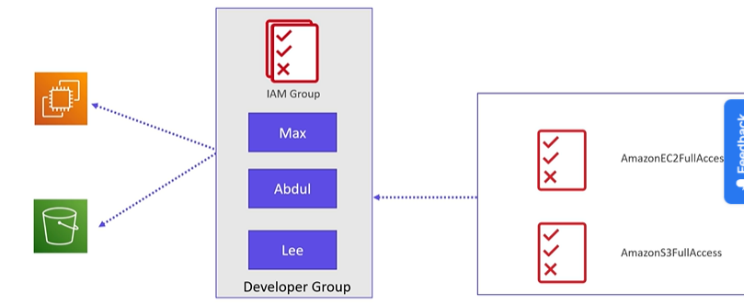

* AWS Resources can access other resources using AWS IAM roles. An IAM role allows us to securely grant access to an AWS service to act on other AWS service in the account. Programmatic access is configured to give access one service to other service.
* IAM roles can be used to provide access to AWS services from other AWS account or applications to interact with services in AWS.

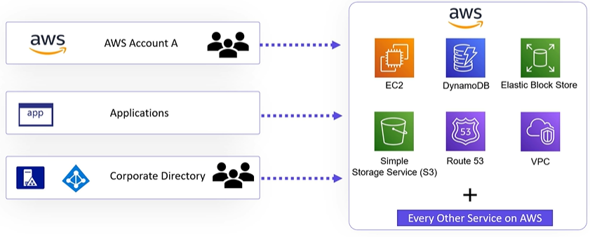

* User can create custom policies.

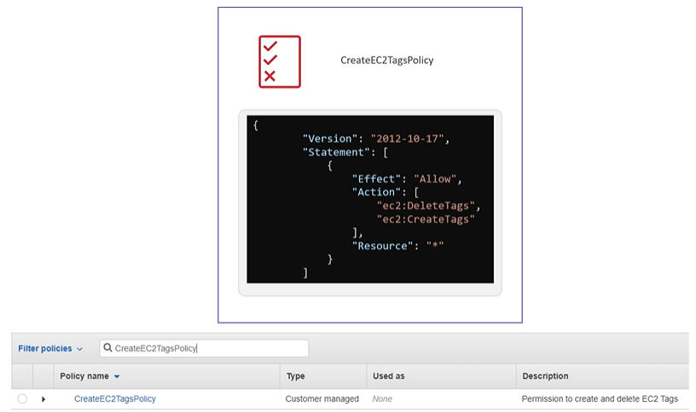

### Programmatic access:

#### Process to install AWS CLI:

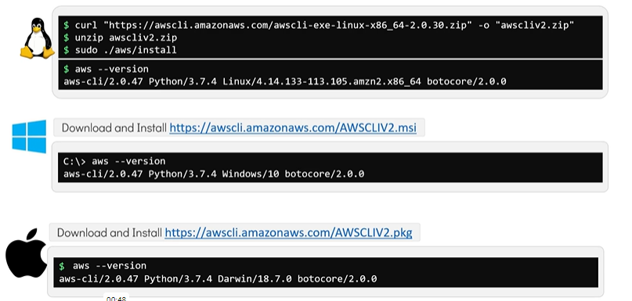

After installing AWS CLI we need to configure it as follows.

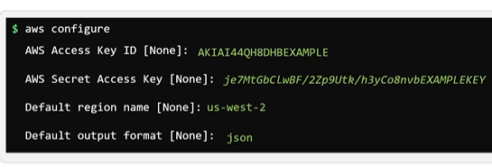

After configuring AWS CLI data is available in hidden directory .aws directory as follows.

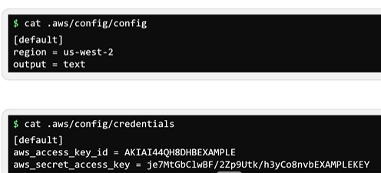

#### AWS command syntax:

command: It is a service name

subcommand: It is operation to be performed on service

options and parameters: various options and parameters used to perform subcommand

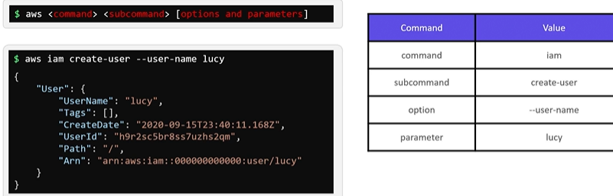

ARN: Stands for AWS Resource Name and it is a unique name allocated by AWS to every resource.

We need not to memorize each command instead we can use help as follows.

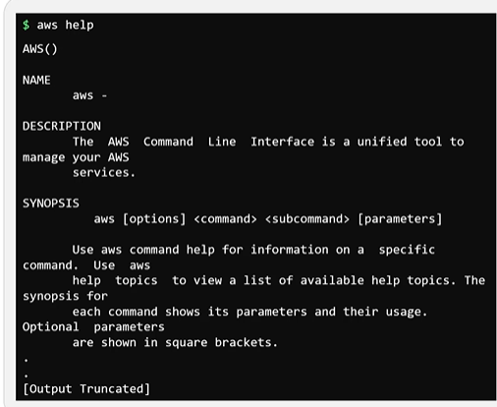

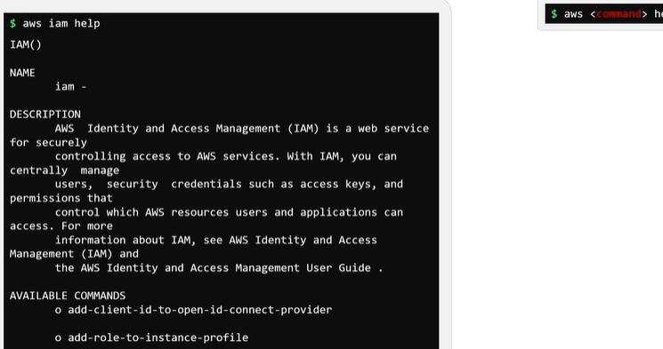

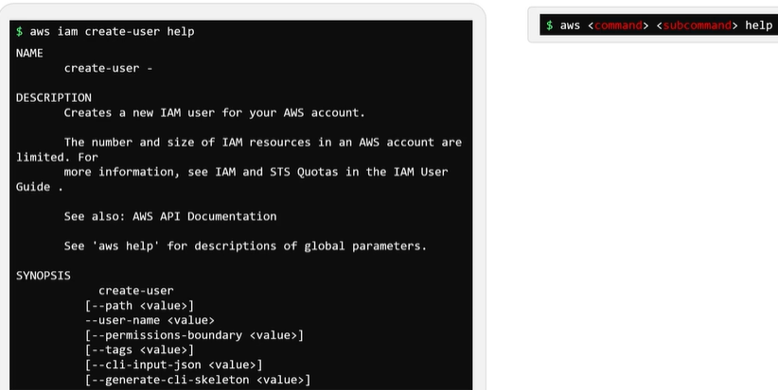

#### Some AWS CLI Commands:

aws --version

aws iam help | grep -i list

aws iam list-users --endpoint <http://aws:4566>

aws iam create-user help

aws iam create-user --user-name mary --endpoint <http://aws:4566>

export endp="--endpoint <http://aws:4566>"

cat /root/.aws/config

cat /root/.aws/credentials

aws $endp iam attach-user-policy --user-name mary --policy-arn arn:aws:iam::aws:policy/AdministratorAccess

aws iam create-group --group-name project-sapphire-developers $endp

aws iam add-user-to-group --user-name jack --group-name project-sapphire-developers $endp

aws iam add-user-to-group --user-name jill --group-name project-sapphire-developers $endp

aws iam list-attached-group-policies --group-name project-sapphire-developers $endp

aws $endp iam attach-group-policy --group-name project-sapphire-developers --policy-arn arn:aws:iam::aws:policy/AmazonEC2FullAccess

### AWS IAM with terraform:

#### Procedure to add user using terraform:

* Provider is AWS
* Resource type is iam_user
* Resource Name is admin-user

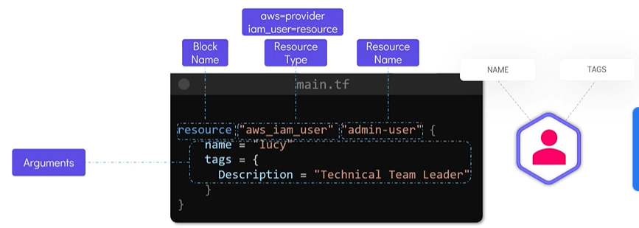

* Without any configuration terraform init then plan commands will show following output.

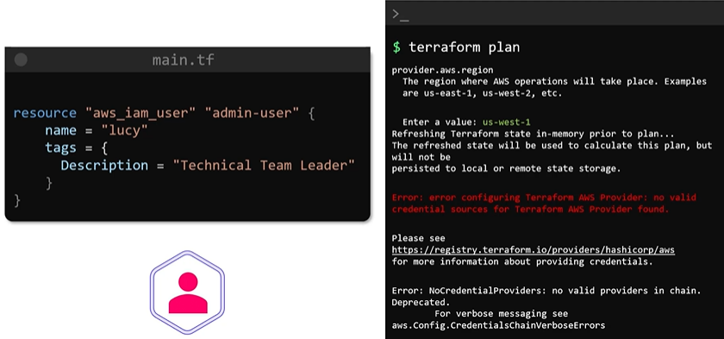

* It will ask to enter default region and error message indicates there is no valid credentials.
* We can configure provider block as shown below.

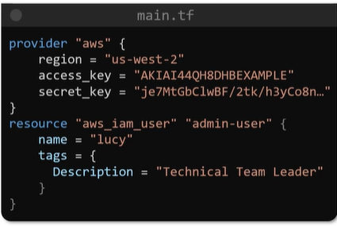

* But such hardcoded approach is not recommended. Recommended approach is to provide details in credential file.

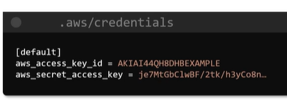

* We can feed credential details as an environment variable.

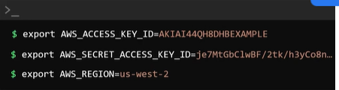

* If all fields of provider block are exported as environment variable then provider block is not required in configuration file.

#### ***IAM policies with Terraform***:

* To attach policy to a user create a resource of type iam_policy as shown below.
* Entire policy details in JSON format is available in AWS policy documentation. This can be feed to resource block by using HEREDOC.

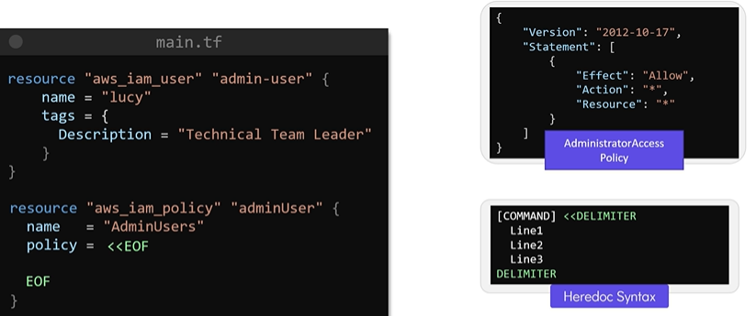

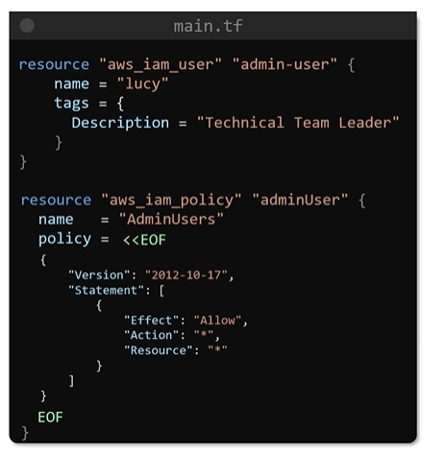

* To attach policy to a user we need another resource block.

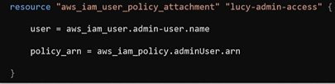

* With terraform apply command policy will be attached to a resource.

#### Another way to attach policy to user using terraform:

* Create admin-policy.json file in same configuration directory and save policy details in JSON format in that file.
* Use file function in configuration file and give reference of policy file as shown below.

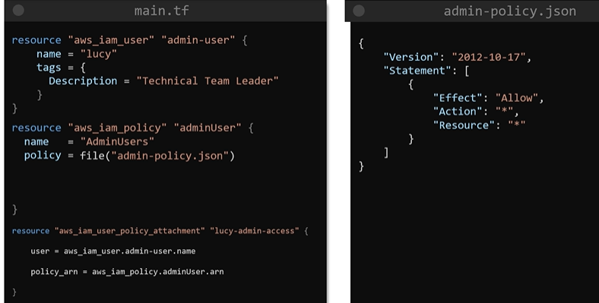

### S3 with terraform:

#### S3 basics:

* S3 stands for simple storage service in AWS.
* S3 is object based storage which stores objects or flat files such as documents, images and videos.

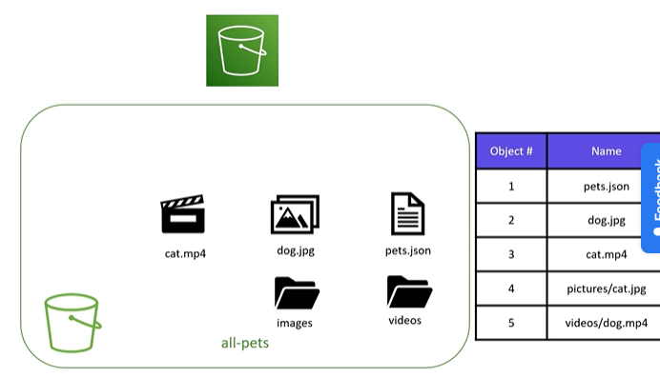

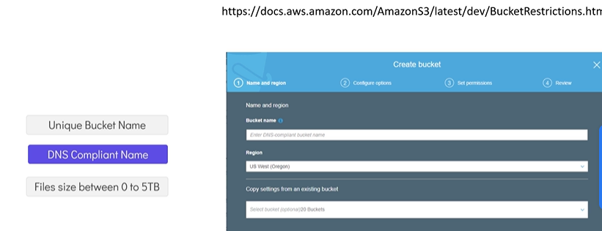

DNS compliant means it shold not end with -, should not have upper case letters, name should be 3 to 63 character long.

#### Bucket web address format:

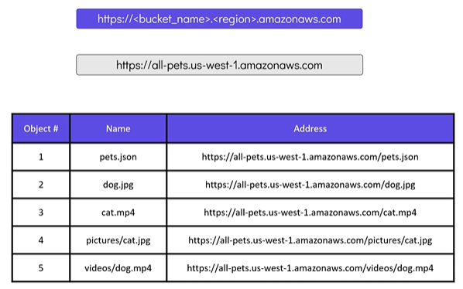

* Access to the bucket and operations that is to be performed in bucket are depends on bucket policies.

#### Procedure to create S3 bucket using terraform:

* To create S3 bucket in terraform we will make use of aws_s3_bcucket resource.
* We have assign resource name.
* We should put unique bucket name as argument optionally. If we have assigned name then terraform will assign random but unique bucket name.
* We can add tag argument optionally.
* With terraform init, plan and apply commands S3 bucket will be created.

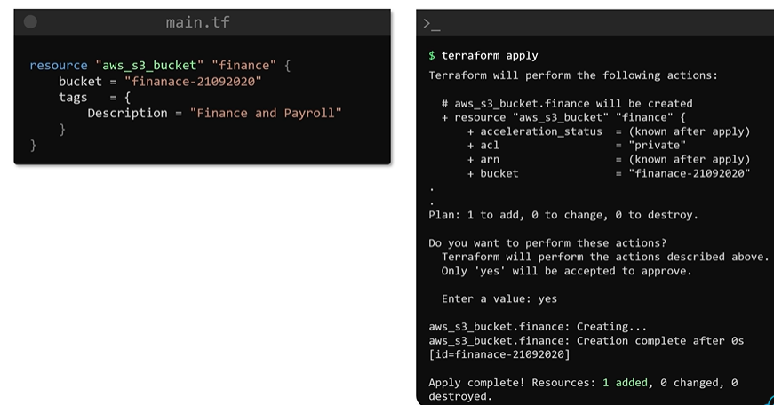

#### Procedure to upload object into S3 bucket:

* It requires resource of bucket object to be created.
* It required three arguments.
  + Content: Path of file to be uploaded.
  + Key: filename.
  + Bucket: name of bucket to which files to be uploaded. We can make use reference expression.

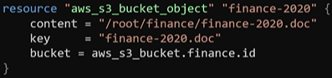

* Both of above resources are created in AWS infrastructure. An state of these resources is recorded in local sate file called terraform.tfstate file.

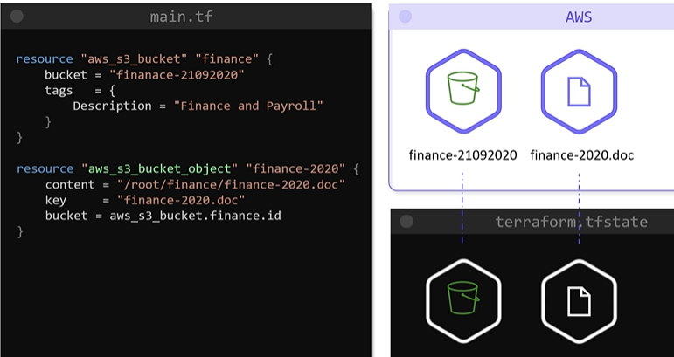

#### Bucket policy:

* Used to define who can access bucket.
* Suppose there is group is created manually. So terraform state is unaware of this group.
* To make bucket accessible to this group we need to create data source for this group. This allows terraform to read attributes of this group.
* Now we can make use of ARN of this group inside bucket policy resource.

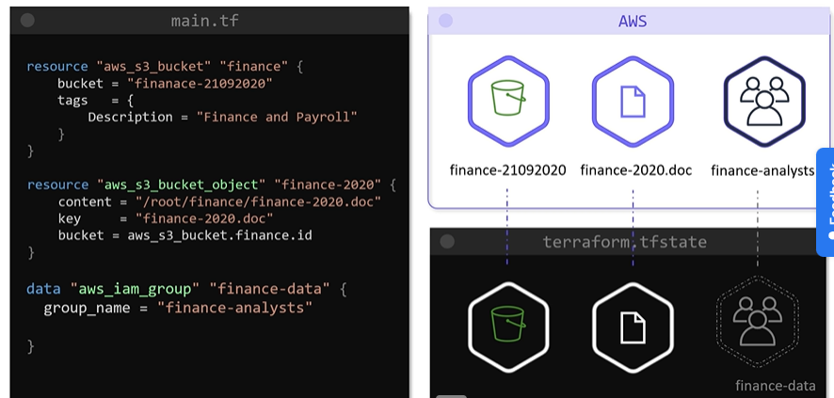

* Another aws_s3_bucket_policy block is defined to attach policy to a bucket. It expects two mandatory arguments.
  + Bucket: requires bucket name as input. User can use reference expression to assign value.
  + Policy: Requires JSON policy document fed using heredoc as follows.

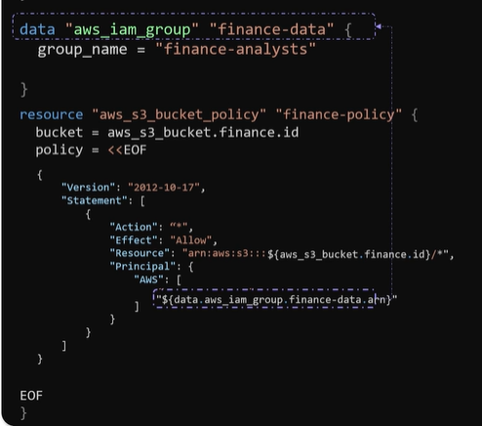

* + Instead of heredoc we can use inbuilt file function and add policy details in that file.

### Dynamodb in terraform:

#### Introduction to dynamodb:

* It is a NoSQL database solution provided and fully managed by AWS. It stores data in key-value pairs and documents.
* Each entry in database is called item. Each item has primary key (Mandatory attribute) using which we can uniquely identify it.
* Each item has one or more attributes which provides meaningful info about items. But having all attributes to each item is not mandatory.

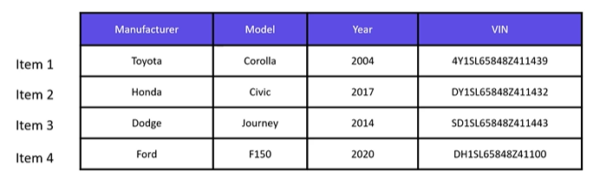

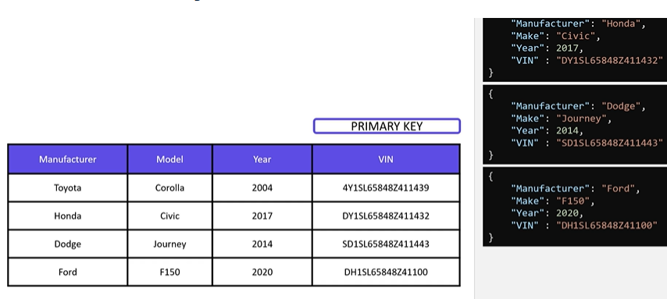

* Items can be represented in JSON format.
* It is highly scalable database that can cope with millions of requests from applications.
* No servers that user have to manage. AWS offloads operational tasks such as database upgrades, software installation and patching from users.
* Dynamodb guarantees high availability and low latency as data is replicated across multiple regions.

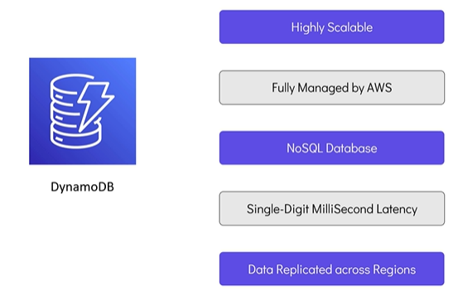

#### Procedure to create dynamodb table using terraform:

* Required mandatory attributes
  + name: required name of table
  + hash_key: required attribute of table which is unique and used to identify items of table uniquely.
  + Other attributes defined inside attribute block within resource block as follows.

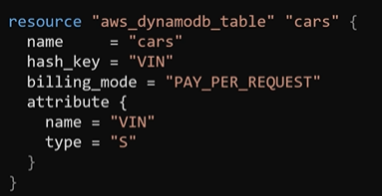

* An argument expect the value to be in a JSON representation with type and value split as shown.

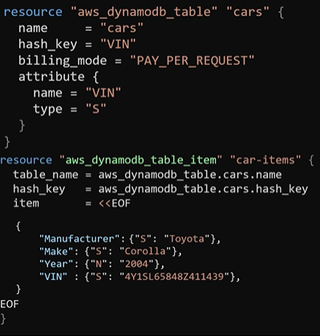

### AWS EC2 Basics:

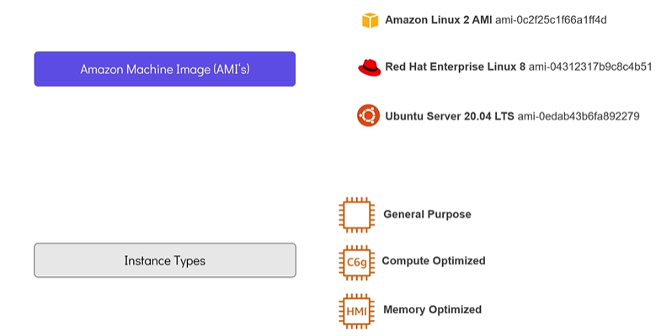

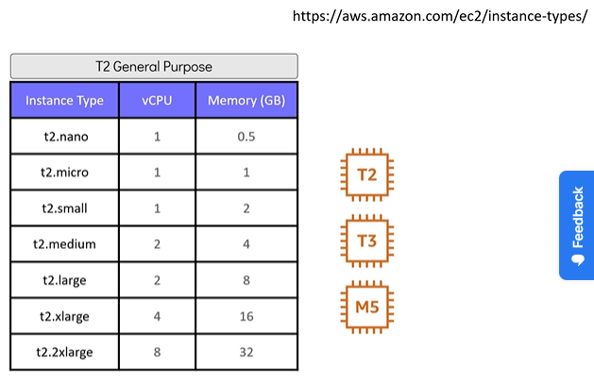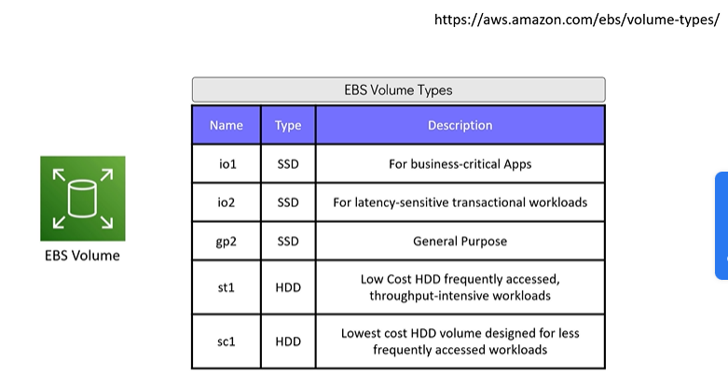

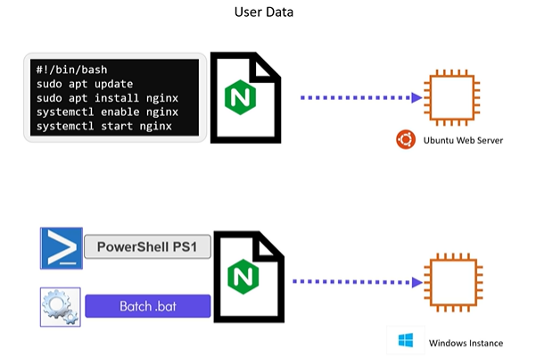

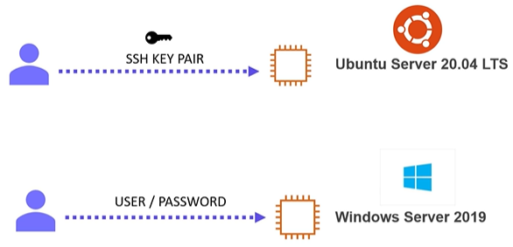

### Terraform Procedure to deploy EC2 instance:

* Need to define resource block of “aws_instance” provider as follows:
* It requires two mandatory arguments:
  + Ami id
  + Instance type
* We can feed optional argument tag to identify EC2 instance.
* We can feed bash script to be run using heredoc as follows.

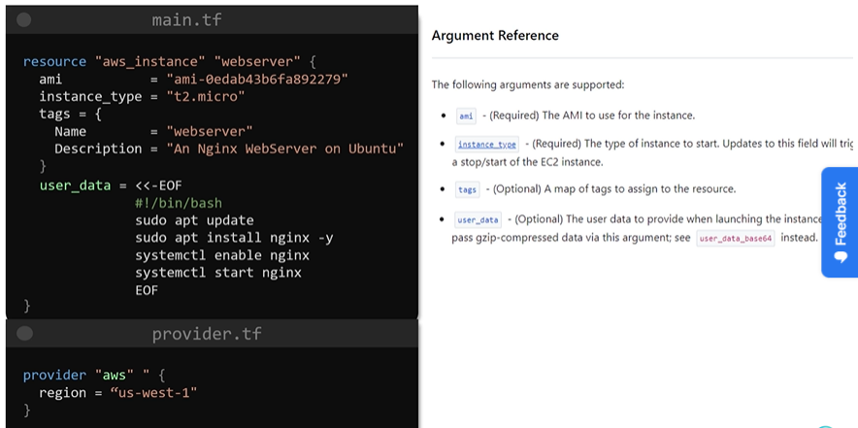

* With terraform plan and apply command we can create an EC2 resource.
* To access EC2 instance we need another resource block of type aws_key_pair which requires path of public key file as an argument.

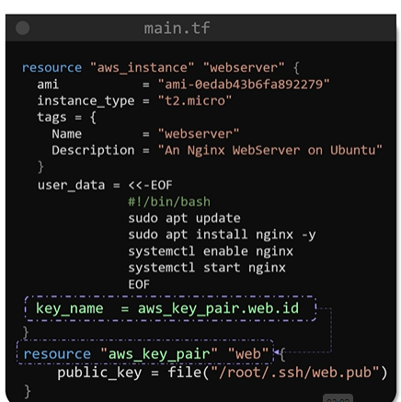

* User can define contents of public key directly.

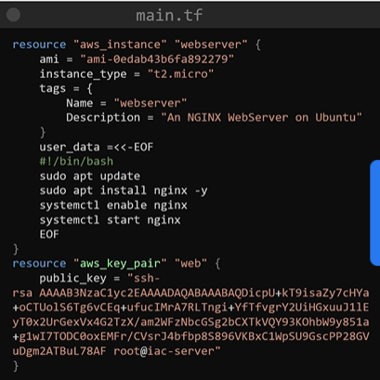

* We need to define another resource block of type aws_security_group as follows.

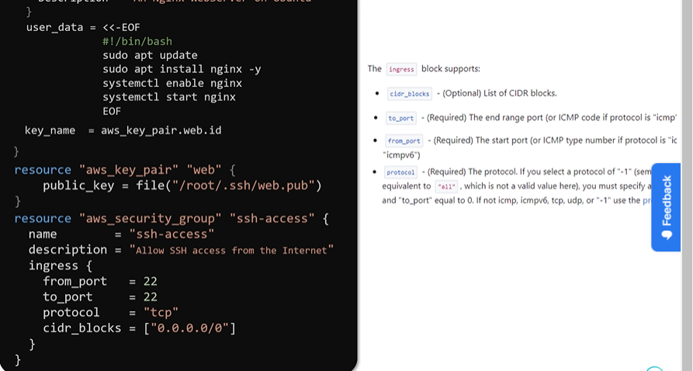

* Give reference of security group inside EC2 instance resource block as follows

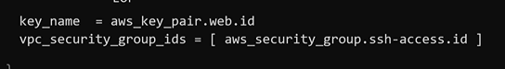

* Use output variable to get public IP of instance as follows.

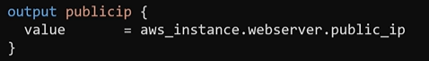

## Remote state:

### Remote state and state locking:

* Working with team saving state file locally is not feasible option also saving state file on version control system repo is not safe as it contains sensitive data.
* So it is recommended and safe to save state file in remote data storage.
* Let’s consider scenario in which we have stored state file in git repo and team using that state file to update configuration.
* In this scenario there are two disadvantages.
  + In this scenario each user will fetch state file from git repo, update infra and again commit state file into git repo.
  + Sensitive information such as passwords, IP address etc. is part of state file and keeping such file in git repo is not recommended from security perspective.
  + State file may get corrupted due to concurrent operations from multiple users.

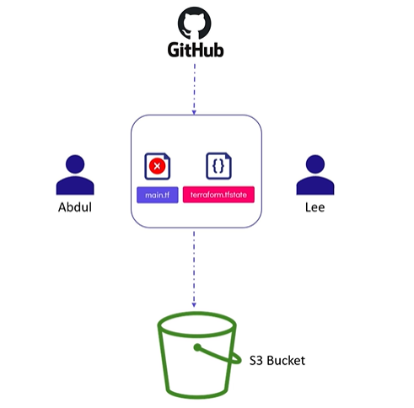

* Terraform protects itself from getting into such situation where concurrent operations happens against same configuration.
* This is achieved by locking state fie during one operation is in progress. As a result other user will not able to run any operation from second terminal until the first operation finishes. This feature is called state locking.

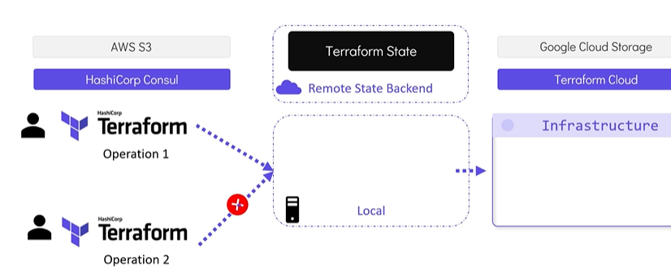

* Version control system such as github does not supports this feature.
* It may happen that user may use older version of state file which leads to rollback or deletion of any of resources provisioned.
* To avoid all such consequences state file is saved to shared storage such as AWS S3 bucket, hashicorp consol etc.
* When remote back end is configured terraform will download the state file from the shared storage every time it is required by a Terraform operation.
* It will upload the updated Terraform state file after each apply.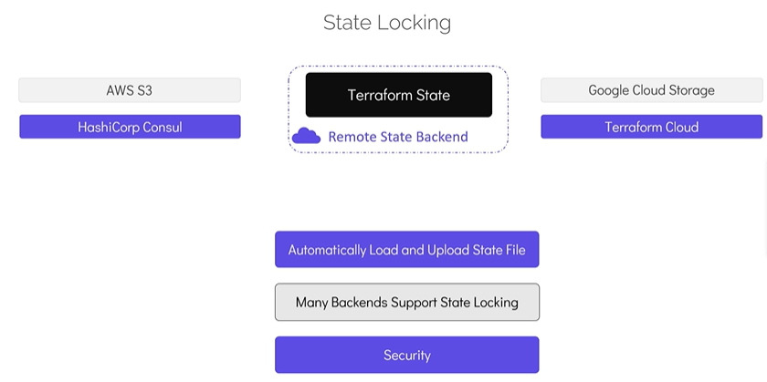

### Dependency lock file:

It has three purpose:

* Consistency
* Reproducibility
* Compatibility assurance

### Lock file has following contents:

* Exact version
* Provider checksum
* Information
* terraform init -upgrade => Used to upgrade lock file in case terraform version is upgraded.
* Best practice for lock file is commit the lock file and review the lock file for changes.

### Types of remote state backend:

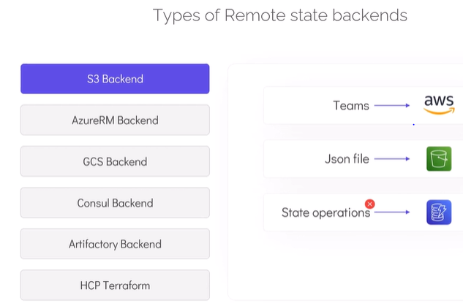

### Procedure to configure remote backend with s3:

* It requires s3 bucket (to store files) and dynamodb table (for constancy check).

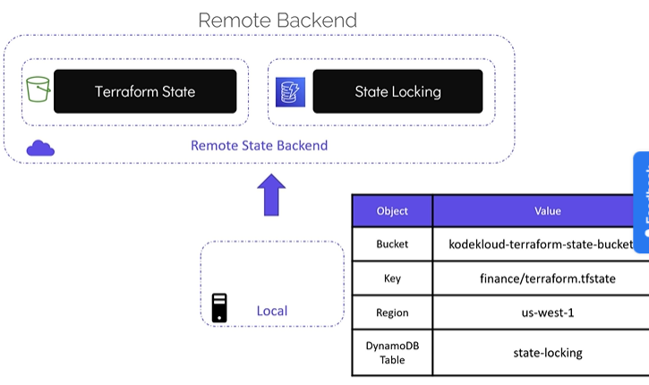

* After creating bucket and dynamodb table keep note of parameters listed above.
* Add terraform block in main.tf configuration file or Add terraform.tf file in configuration directory with following contents.

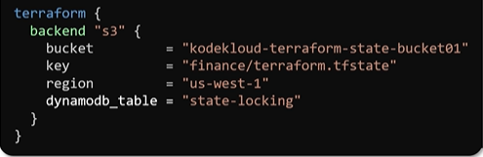

or

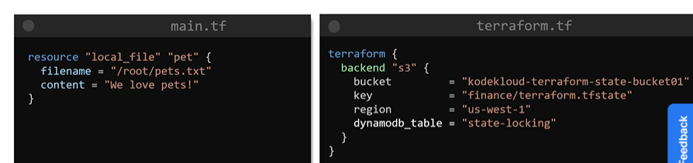

* Reinitialize remote backend with terraform init command.
* init process provide option to copy local state file to remote s3 storage. With yes input terraform will copy state file to remote s3 backend.
* Terraform plan and apply command with lock remote state file and download file locally. Infra Changes will be provisioned, state file updated accordingly and uploaded to s3 backend again. Once operation is completed lock of remote file will be released.
* The state file will not be stored local configuration directory.

### Terraform state commands to modify stae file:

* Terraform state followed by pull, list, remove, show etc. used to list, pull or manipulate state file.

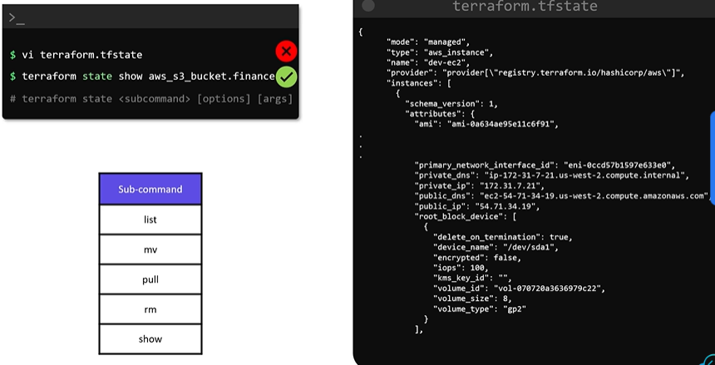

#### terraform state list

* used to list resources recorded in state file.

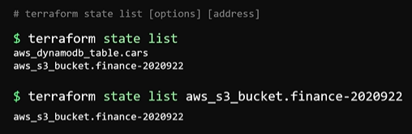

#### terraform state show

* display attributes of single resource from state file matching with given address.

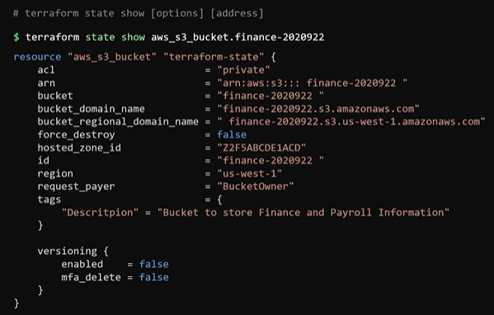

#### terraform move

* Used to move items in terraform state file.
* Moving item means
  + Moving resource from its current address to another (renaming a resource).
  + Or move items from one state file to another state file maintained by a different

Configuration directory.

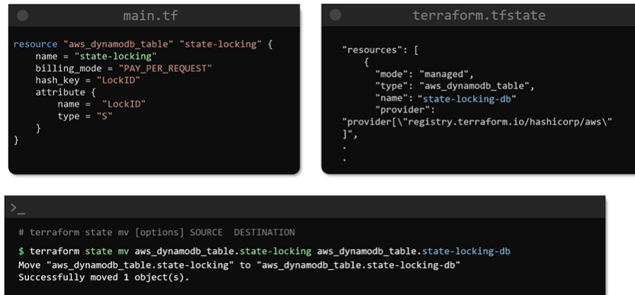

* Then you must manually change resource name in configuration file of configuration directory.

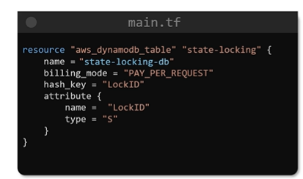

* With terraform apply command there will not be any change.

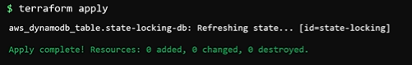

#### Terraform state pull command

* Used to download and display remote state on the screen.
* The output of this command can passed to JSON query tools like JQ to filter required data.

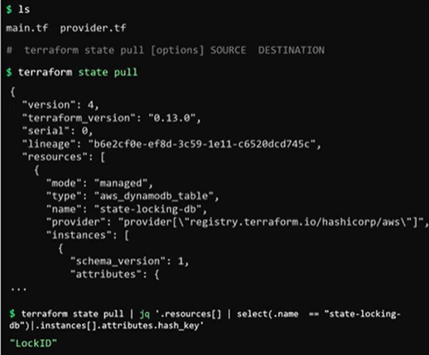

#### Terraform state rm or remove

* Used to delete item from terraform state file.
* Used when you no longer wish to manage one or more resources via terraform configuration and state.
* Make sure that to remove associated resource block from the configuration file.
* With this command resources are removed from state file but not actually destroyed from real world infrastructure.

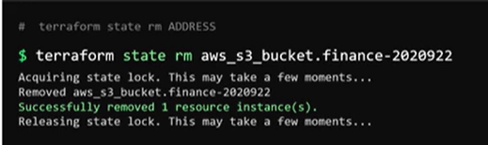

## Terraform Provisioners:

* Provisioner provide ways to carry out tasks such as running commands or scripts on remote resources or locally in machines where terraform is installed.

e.g. exec provisioner is used to run a bash script after a resource is created.

### Remote exec provisioner:

* Provisioner block defined inside a resource block.

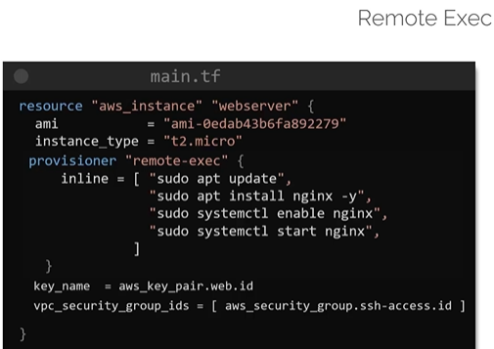

* Merely specifying provision block does not guarantee that commands will work.
* There should be network connectivity between local machine and remote instance.
* Appropriate security group required to get access and pass desired traffic.

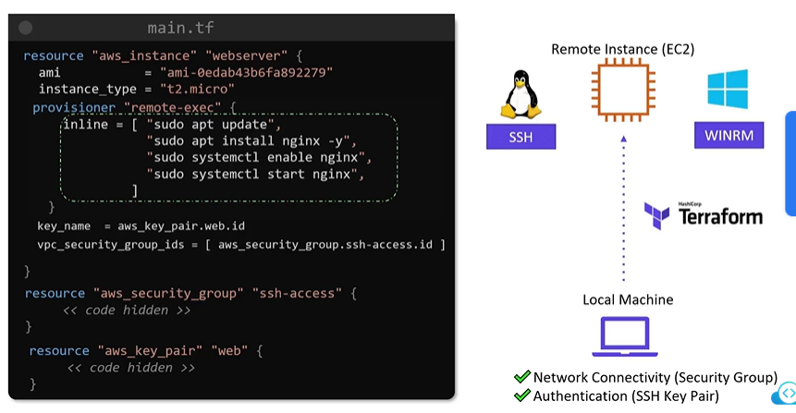

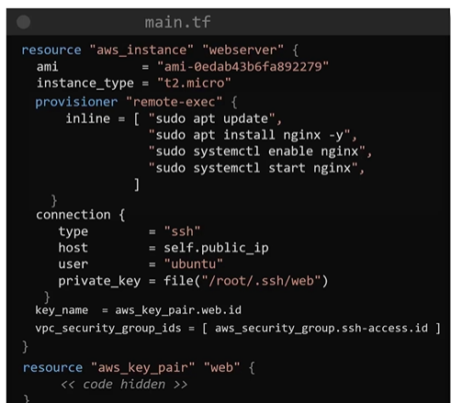

### local exec provisioner:

* Used to run task on local machine where we running terraform binary and not on resource created by terraform.
* This is handy when we want to gather some data and write into a file locally.
* This is written inside resource block similar to remote provisioner.

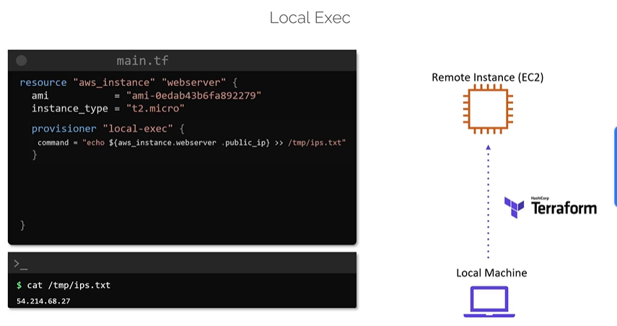

* By default provisioner run after resources are created such type of provisioner is called create time provisioner.
* Some provisioner run before resources are destroyed. Such provisioner is called destroyed time provisioner.
* This is set by specifying event argument and specifying its value as destroyed destroyed within provisioner block.

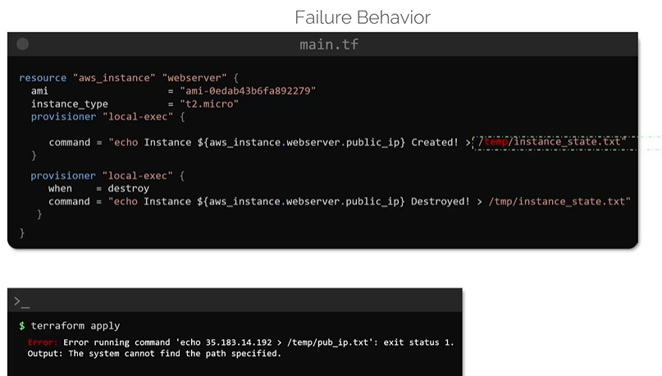

* If command or script within provisioner block fails the terraform apply operation also error out.
* If we specify failure argument inside provisioner block. Any resource that is created while provisioner fails is marked as tainted in terraform.
* If we set failure argument value to continue then resource will get created successfully even if provisioner command or script fails.

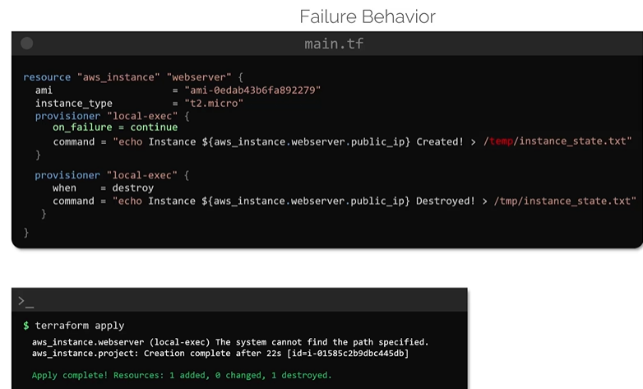

* Terraform recommends to avoid provisioner wherever possible and make use of options natively available for the resource types for the provider used

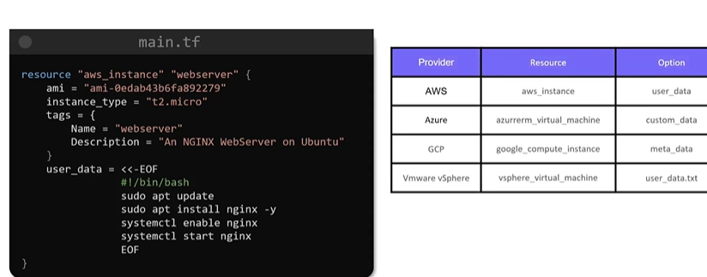

### Terraform script to create EC2 instance:

variable "ami" {

default = "ami-06178cf087598769c"

}

variable "instance_type" {

default = "m5.large"

}

variable "region" {

default = "eu-west-2"

}

resource "aws_instance" "cerberus" {

ami = var.ami

instance_type = var.instance_type

key_name = "cerberus"

user_data = file("./install-nginx.sh")

}

resource "aws_key_pair" "cerberus-key" {

key_name = "cerberus"

public_key = file(".ssh/cerberus.pub")

}

resource "aws_eip" "eip" {

vpc = true

instance = aws_instance.cerberus.id

provisioner "local-exec" {

command = "echo ${aws_eip.eip.public_dns} >> /root/cerberus_public_dns.txt"

}

}

### Considerations with Provisioners:

* Making use of provisioner increase complexity of configuration.
* With use of provisioner terraform plan has no way to accurately model actions of a provisioner.
* For remote provisioner network connectivity required local and resource to be created also authentication must be established once resource is created.
* It is recommended to use native provisioners of resource e.g. user_data is native feature of AWS.
* It is recommended that keep post provisioning task minimum and build custom images that have all required software and configuration required for resource.

## Terraform Import, Tainting Resources and Debugging

### Terraform Taint:

* Terraform mark some resources as taint and during subsequent apply command execution resource will be recreated by destroying existing resource.
* Sometimes resource creation fails with terraform apply command. Terraform marks such resource as tainted and can be seen with terraform plan command. Such resources will be attempted to be recreated during subsequent apply command.
* Suppose someone has done some manual changes in resource created using terraform. In such scenario if you want to recreate such resource then taint that resource and use terraform apply command.

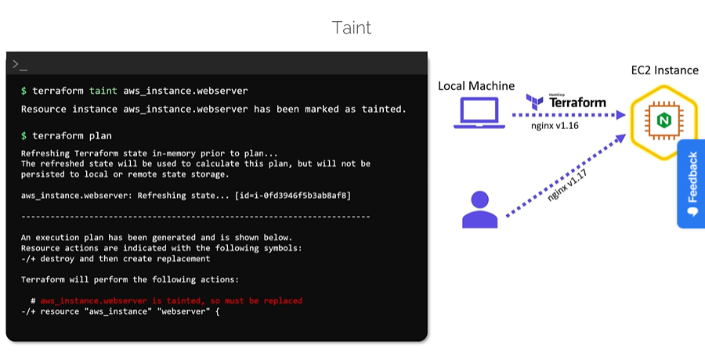

* To undo a taint use untaint command and with it terraform will not create such resource during subsequent terraform apply command.

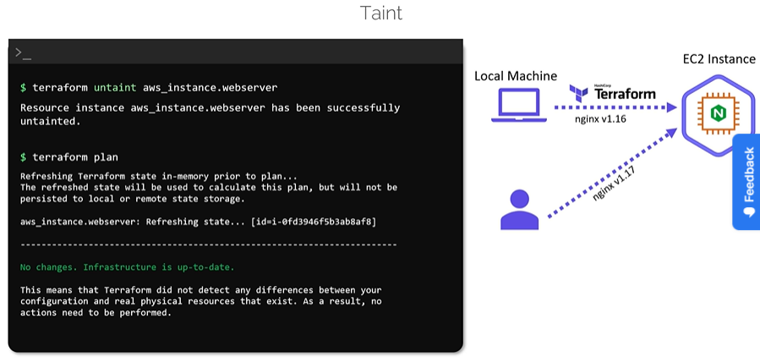

### Debugging in terraform:

* Terraform apply command shows good amount of useful info which gives idea about what has happened.
* But when things are wrong and we want to debug things in detail we should export environment variable TF_LOG to certain value called log level. This show more detailed output in case of terraform apply command.
* There are 5 level of log levels.
* TRACE is most commonly used log level which gives most verbose output among all log levels.

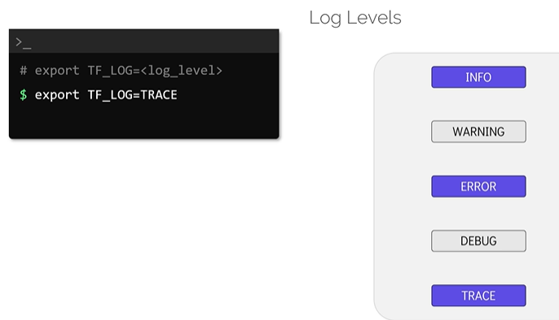

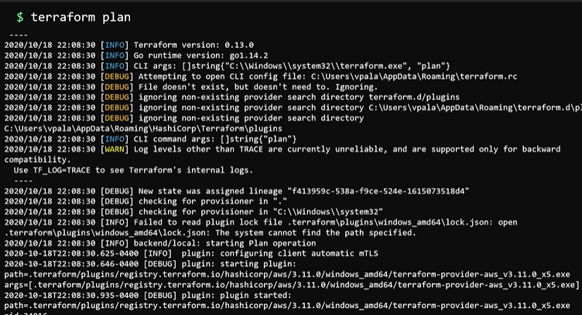

* With TF_LOG_PATH environment variable we can set default path of file to save logs.
* We can unset environment variable when things are normalized and debugging is not needed. This displays normal output suing terraform apply command.

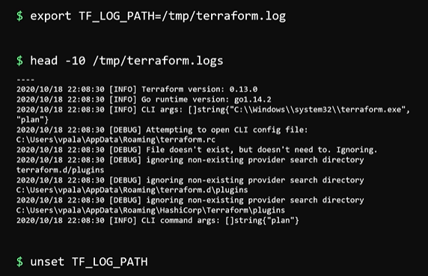

### Terraform import:

* Resources created manually or created by other IaC tools can be imported into terraform using terraform import.
* Data sources are used to read data from resources created manually or using other IaC tool.
* With this we just read attributes but to bring that resource in control of terraform we need to use terraform import as shown below.

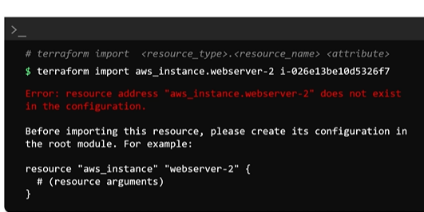

* Our configuration file is within the directory is not updated with import just state file is updated with details of infrastructure being imported. Hence error will be disppalyed during first time import.
* We have to make changes manually in configuration file with details of resource to be imported. To fix this error add empty block.
* terraform import command will not show any error this time.

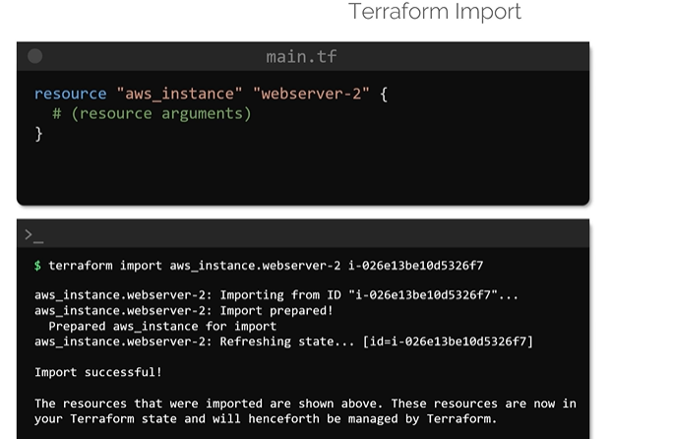

* Update the configuration file by referring attributes of imported resource from state file.
* Once all arguments and their appropriate values updated terraform plan command will refresh the state and understand that resource exist and no action required.
* Now the resource is under control of terraform.

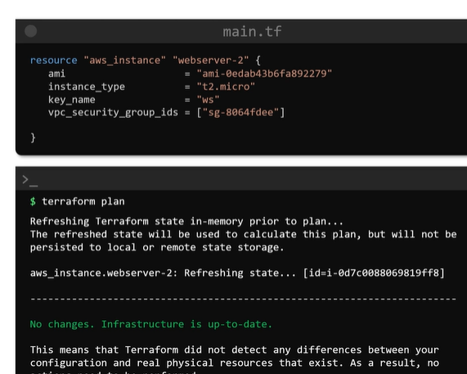

## Terraform modules:

### Terraform module definition:

* For longer codes with number of resource definitions there are disadvantages as follows.
  + Complex configuration files
  + Duplicate code
  + Increased Risk
  + Limits Reusability
* These limitations cab be overcome using modules. Module is configuartion directory having set of configuration files.

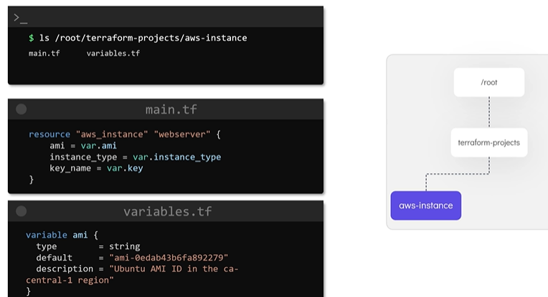

* Suppose we want to use configuration files of aws-instance directory to another directory called webserver we can create another block called module inside main.tf file of webserver directory.

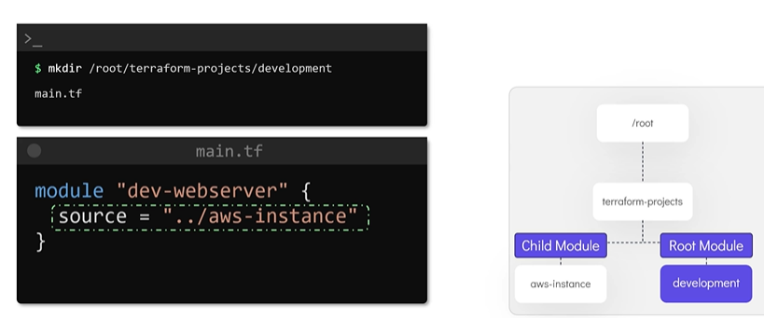

* We can use absolute path also to specify path of source modules.

### Creating and using modules:

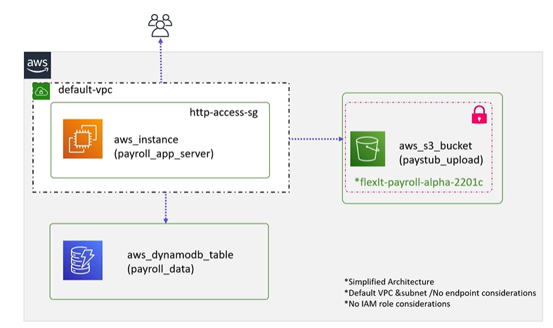

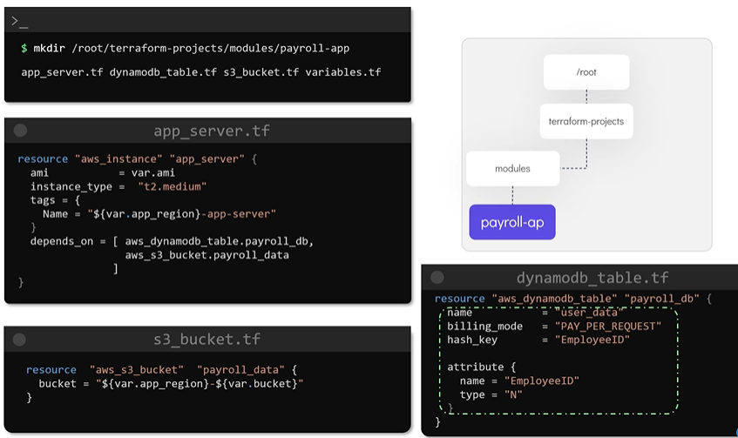

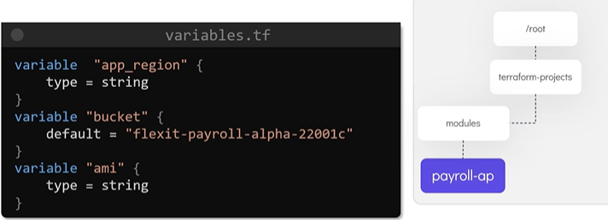

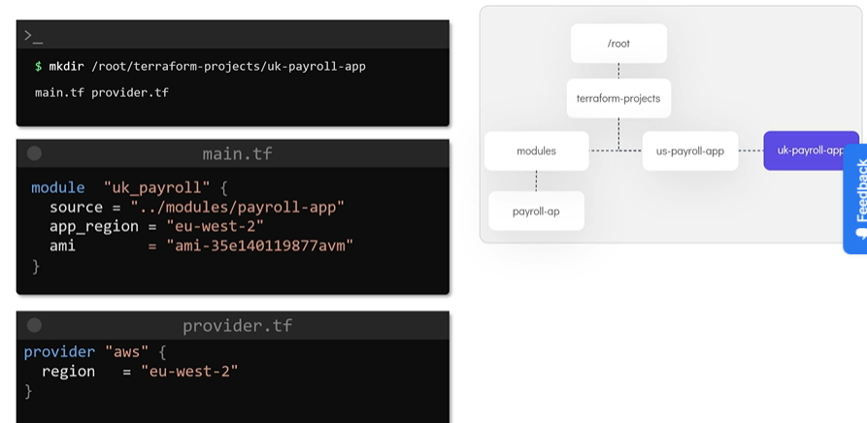

With terraform init, plan and apply resource will be created and corresponding files of resource is created inside current configuration directory.

### Using modules from registry:

* Terraform registry can be used as repository to store modules.
* Based on provider modules are grouped in registry and available to anyone to provision infrastructure.
* There are two types of module available in registry.
  + Verified module: tested and maintained by hashicorp and has blue tic. E.g. aws security group module.

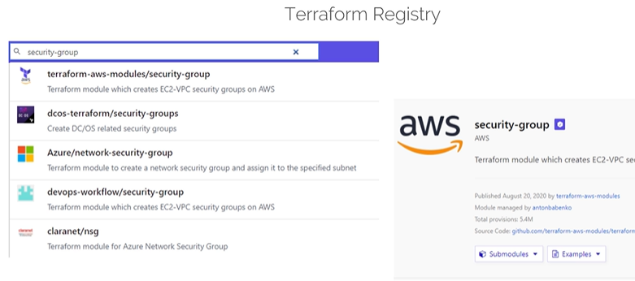

* + Community module: published by users or community but not verified by hashicorp.
* Modules from registry have information about publisher, different versions and instructions how to use it.
* Module may have submodules which have some predefined specific requirements covered inside it.

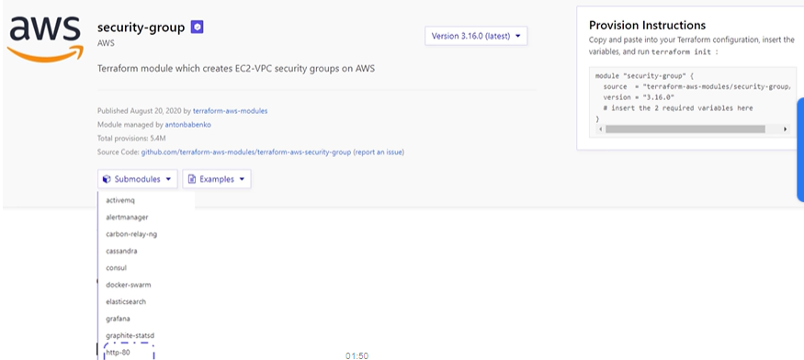

* Some of the values of module parameters change based on our local input.
* It is recommended to specify required version or terraform will download latest version of module.
* Terraform get command will only download modules from registry I case terraform is already initialized and providers are downloaded.

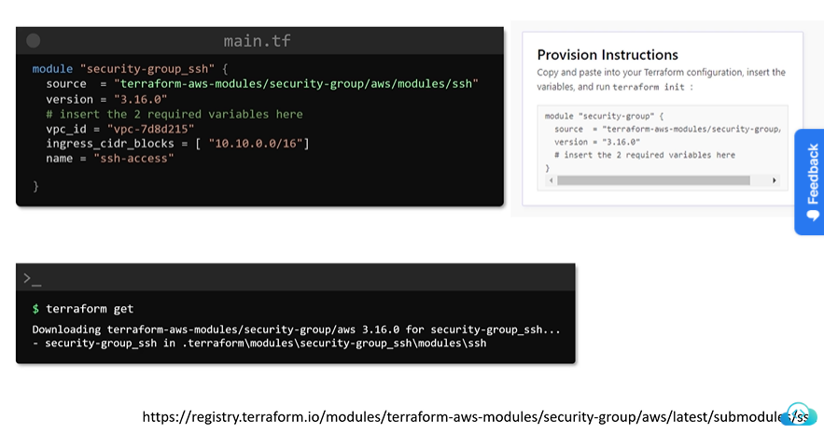

## Terraform Functions and Conditional Expressions

### Terraform functions:

* Terraform provides interactive console to test functions and interpolations.
* terraform console command is used to get into interactive mode.
* Interactive console loads the state associated with configuration directory by default.
* It allows us to load and pass any values (currently stored in state file) and variables (from configuration file) to functions.

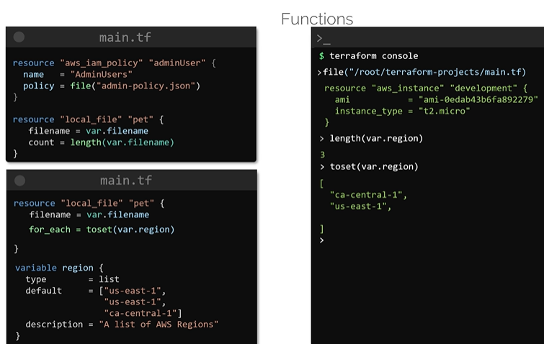

### Some Functions types of terraform:

#### Numeric functions:

* Used to transform and manipulate numbers.

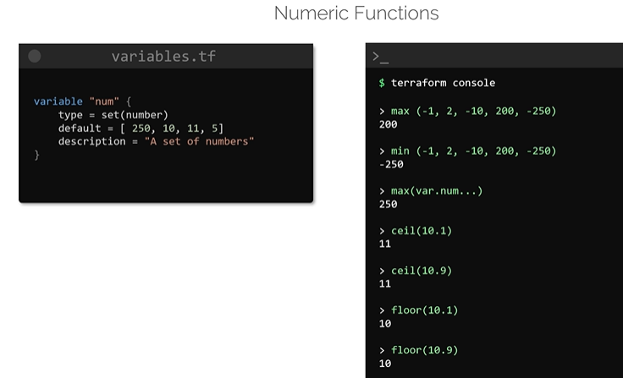

#### String functions:

* Used to manipulate strings.

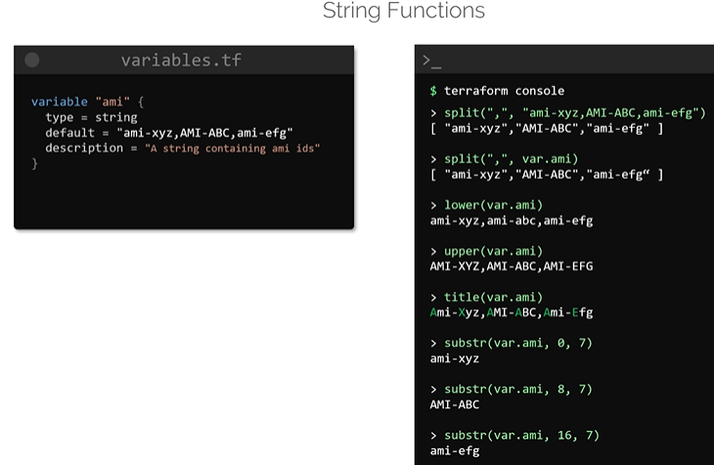

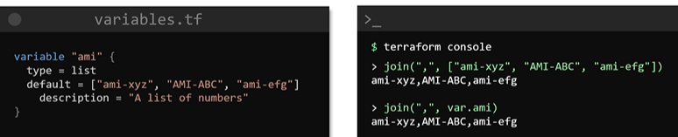

#### Collection functions:

* Used for collections data types such as set, list and map.

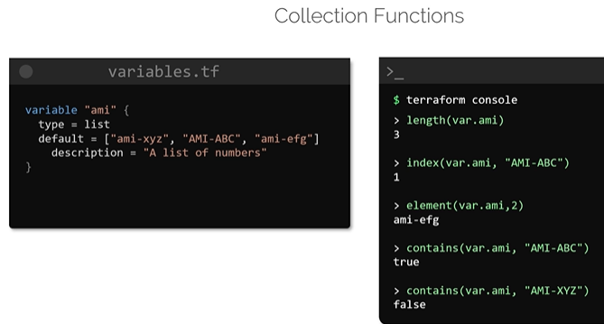

#### Map functions:

* Used to manipulate or perform operations on maps and there elements.

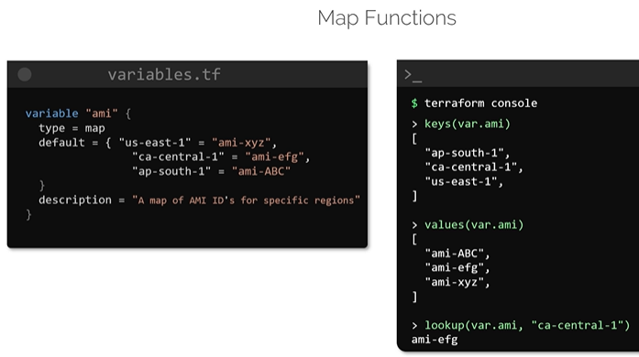

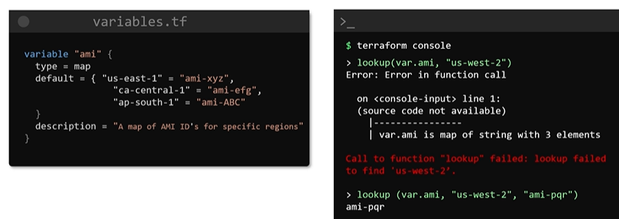

### Terraform operators and conditional expressions:

* Using terraform console we can perform arithmetic and logical operations.

#### Arithmetic operators:

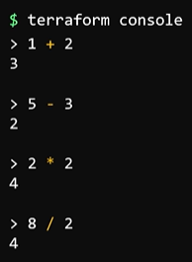

#### Equality operators:

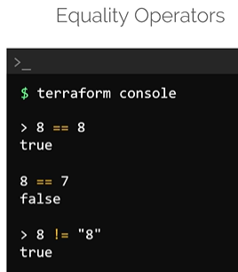

#### Comparison operators:

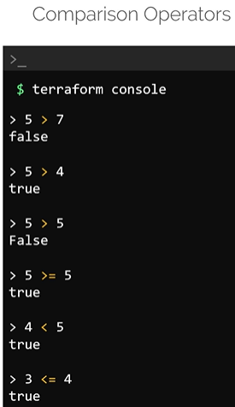

#### Logical operators:

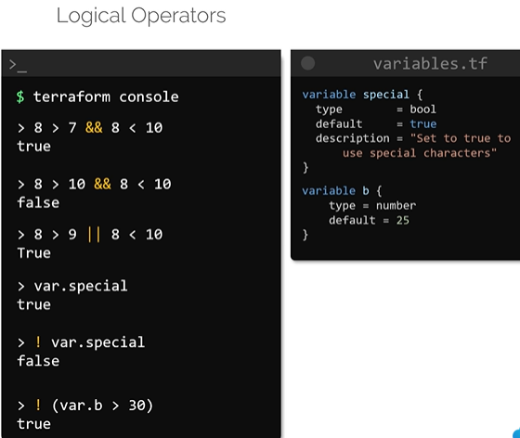

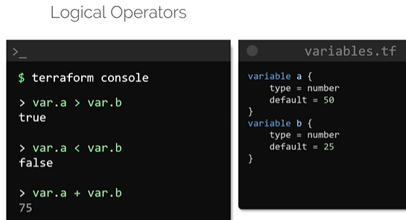

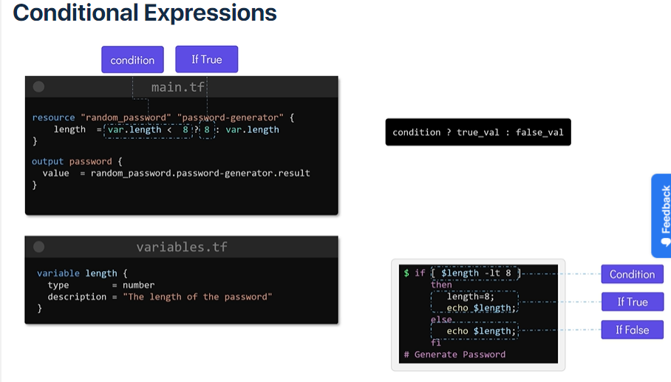

### Terraform Workspace:

* To replicate same resources with current approach we need to create new configuration directory, copy configuration file, do the required changes and create corewponding resources.
* To avoid this repetitive work we use workspace.
* We can create multiple workspaces within configuration directory and can use same configuration files.

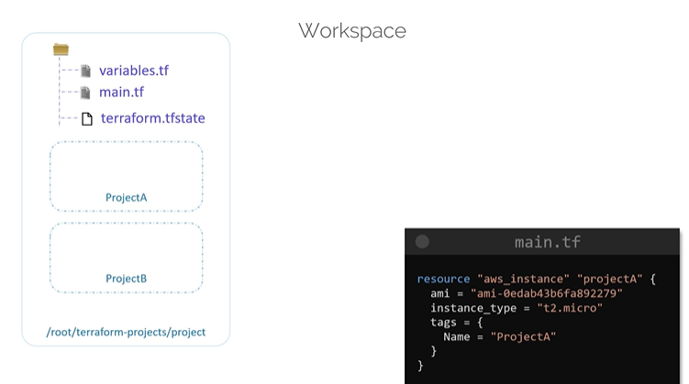

* We can create and list workspace as follows.

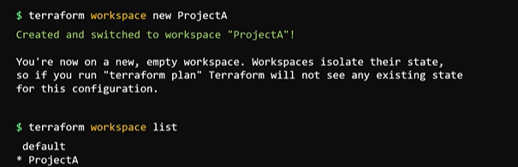

### How to use workspace:

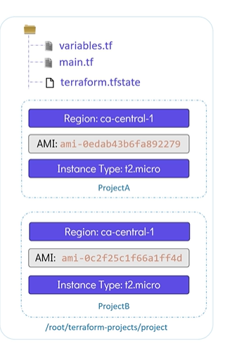

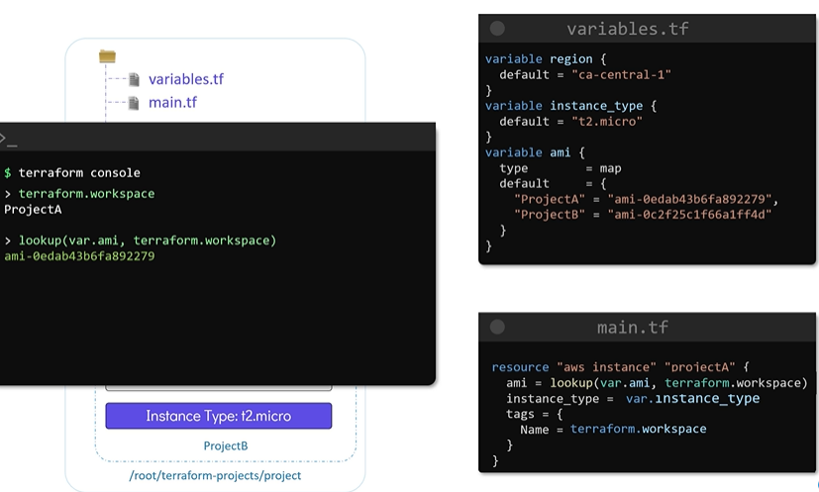

* To create resources switch to corresponding workspace and use terraform apply command.

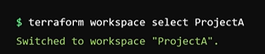

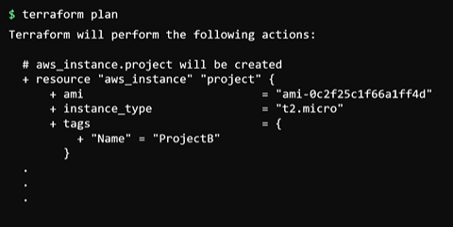

* State files of individual workspaces are saved to /.terraform.tfstate.d directory.

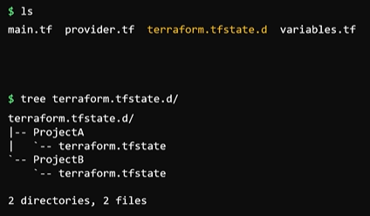

**Terraform Cloud:**

When multiple people working on project, they may have different versions of terraform due to part of requirement of other projects on which they are working. This may lead to inconsistency. To overcome this challenge, we can use terraform cloud. Terraform cloud has several other features.

* Shared state
* Consistent and reliable environment
* UI Interface
* Secrete Management
* Access Controls
* Private Registry
* Policy Controls

URL: app.terraform.io for terraform cloud.

After creation of account and credential validation we have to create workspace.

Terraform cloud workspace has three options:

* Version control workflow: Used to integrate terraform with VCS systems such as github, gitlab.
* CLI Driven: It allows terraform run from local machine but executing operations remotely on terraform cloud.
* API driven: Used to integrate terraform into large pipelines using Terraform API.

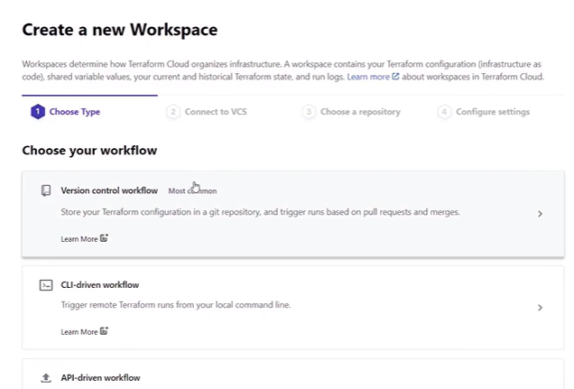

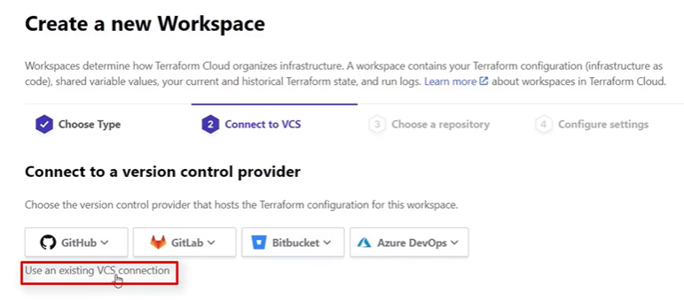

Choose the repository:

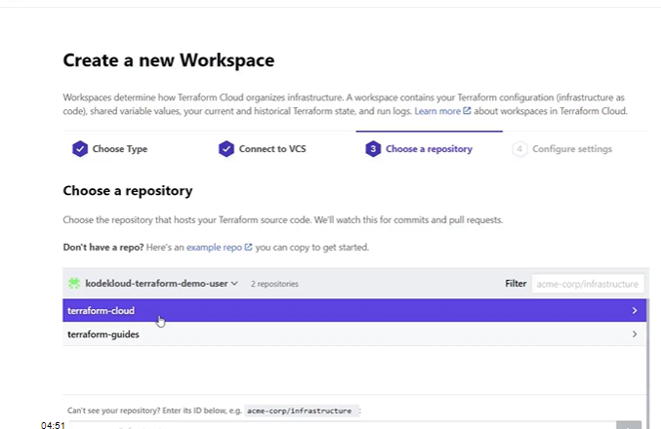

Name and create workspace:

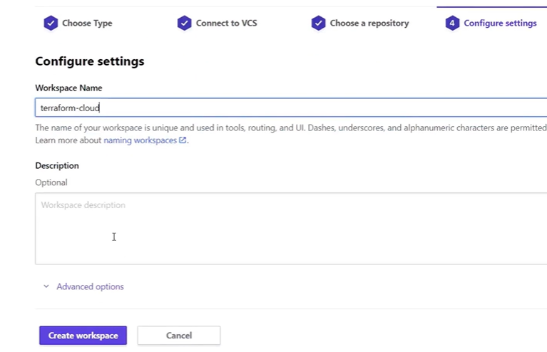

* We need to define variables under variable tab.

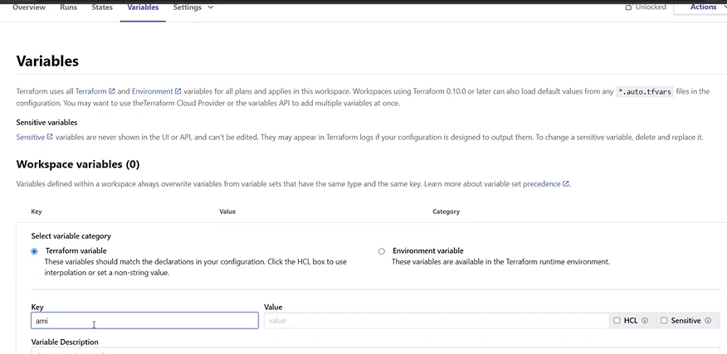

* Use sensitive option to configure aws credentials like access_key and secrete_key_id
* Go to runs and under actions tab, click on start new plan, select required plan and click on start.

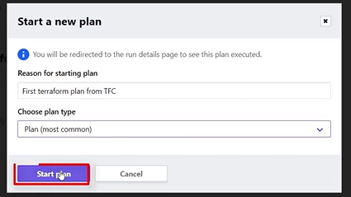

* Review the plan and click on confirm and apply to provision resources.

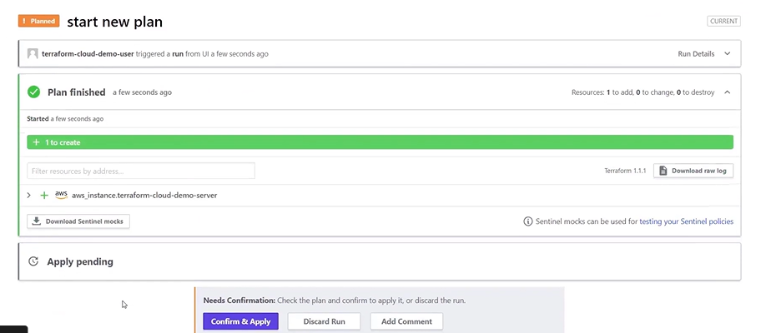

* Destruction and deletion option under settings tab is used to delete resource.
* We can change plan using plan and billing option from settings tab of terraform icon.
* Various options such as organization settings, users, plan and billing, policy, policy sets are available in settings tab.

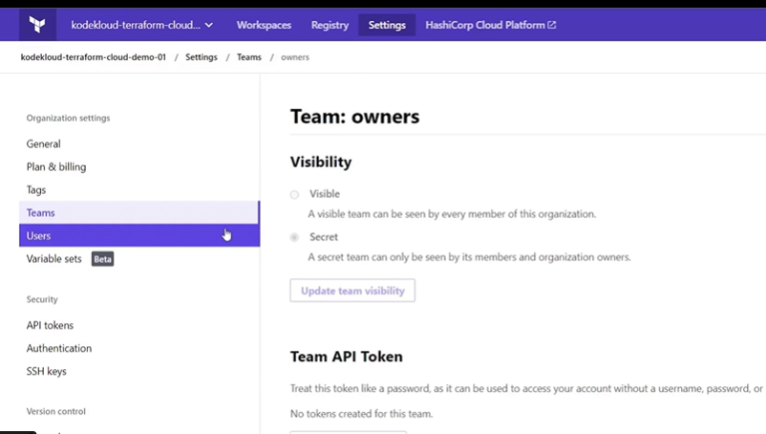

* We can publish own provider and modules using registry tab.
* Sentinel policies are used to restrict change of resource parameters to undesired values.

E.g. change in ec2 instance type can be restricted.

* Policy option allow us to add individual sentinel policy that can be used within our workspace.
* Policy set option allow us to enforce group of sentinel policies at once and also supports VCS integration. We can define required sentinel policies from github repository and can apply it on desired or all workspaces. We can define sentinel policies with .sentinel file and use those in .hcl file to apply on workspace.

**Steps To create Terraform resource:**

1. Create AWS account.
2. Create user with desired details with programmatic access. Provide permissions for required resources such as EC2, EBS, S3, RDS, DynamoDb etc.
3. Install terraform client on your machine.
4. Export AWS credentials (such as AWS_SECURE_ACCESS_KEY, AWS_SECURE_ID) as environment variable.
5. Create terraform.tf file in desired directory of your client machine.
6. Write provider block as AWS and use terraform init command to initiate terraform.
7. Add resource block and refer terraform documentation to provide arguments in resource block as per requirement.

|  |  |  |
| --- | --- | --- |
| Areas of Terraform's behavior that are not determined by the backend: |  | None |
| How does Terraform protect itself where concurrent operations are run against the same configuration? |  | Terraform will lock your state for all operations that could write state, if supported by your backend |
| Which option can be used to disable the state locking for most commands? |  | -lock |
| A requirement has come up which requires you to inspect the state file of terraform configuration. Your terraform script is already configured to work with the remote backend. Which of the following commands would you use to view a specific field in the state file |  | terraform state pull |

Your friend was working on a terraform project but he is unable to execute the **terraform apply** command successfully. As having experience in automation he asks you for help. On further investigation he reported that he already initialized the directory and also ran **terraform validate** command. Even **terraform plan** also ran with no errors. What could be at fault here?

All the statements are true except the bug one.

You are working in collaboration with your team on some project involving automation using terraform. One of the team members modified a resource on the real cloud infrastructure on the azure platform. You want those resources to be reflected in your local machine. Which of the following would you go with:

**terraform refresh** as it only modifies the state file on your local machine.

The terraform graph command is used to generate a visual representation in which format?

DOT

|  |  |  |
| --- | --- | --- |
| Which of the following statements is FALSE about Immutable infrastructure? |  | It ensures updating this way will not lead to failures |

|  |  |  |
| --- | --- | --- |
| Choose the invalid log level values for the TF_LOG environment variable.  *You can set TF_LOG to one of the log levels (in order of decreasing verbosity) TRACE, DEBUG, INFO, WARN or ERROR to change the verbosity of the logs. Also if we set TF_LOG to JSON, it output logs at the TRACE level or higher, and uses a parseable JSON encoding as the formatting.* |  | None of the above |
| Your team is working collaboratively on a project that uses terraform scripts heavily. In your team one team member was not familiar with terraform, so he was making the required changes manually, using the GUI console of that specific cloud provider on the resources provisioned using terraform. Since these unmanaged changes are hampering the efficiency of the team , you want to revert these changes. How would you go about doing this? |  | Use **terraform destroy** and then **terraform apply** commands in this specific order,You will taint the resources that you want removed on the next **terraform apply**. |
| How would you achieve the force replacement of a particular object even though there are no configuration changes? Choose the most appropriate option among the following: |  | Usage of **terraform apply -replace=”<resource_name>” is preferred over**terraform taint` |

Within your Terraform configuration, how can you include the name of the current workspace.

Using ${terraform.workspace} interpolation sequence

You can use **__** to manage multiple non-overlapping groups of resources with the same configuration.

workspaces

What ways do you have to bring resources created by other methods into terraform?

Use **data sources**,Use **terraform import**

Select the invalid subcommand for **terraform workspace** among the following:

rename

You intend to import two resources to your terraform configuration. You executed only the **terraform import** command until now and it worked. Will the **terraform apply** work if executed now?

It will throw an error,We haven’t updated the resource with correct argument values yet

A developer working on a complex set of infrastructure changes needs to freely experiment with changes without affecting the default workspace. How can he achieve that?

Using temporary workspace is preferred over duplication of configuration files.

|  |  |
| --- | --- |
| Which of the following provisioners does not need a **connection** block defined? | local-exec |

|  |  |
| --- | --- |
| Which of the following function is no longer available in terraform: | map() |

|  |  |
| --- | --- |
| Choose the ways available to download the module in your current terraform configuration directory. | terraform init,terraform get |
| What do we call this flat type of module usage: | module composition |
| Which module can call other modules and connect them together by passing output values from one as input values to another. | root |

|  |  |
| --- | --- |
| Is **Terraform Cloud workspaces** same as **Terraform CLI Workspaces**. | No |
| Which feature is used to manage how members of your organization can use modules from the terraform private registry? | Using sentinel policies |
| Which of the following options doesn’t involve when using Sentinel with Terraform Cloud: | None of the above. |

Can we use **dynamic** blocks to generate **meta-argument** blocks such as **lifecycle** and **provisioner** blocks?

*A dynamic block can only generate arguments that belong to the resource type, data source, provider, or provisioner being configured. It is not possible to generate meta-argument blocks such as lifecycle and provisioner blocks, since Terraform must process these before it is safe to evaluate expressions.*

False

Select the options that does not support dynamic block:

*A dynamic block can only generate arguments that belong to the resource type, data source, provider or provisioner being configured. It is not possible to generate meta-argument blocks such as lifecycle and provisioner blocks , since Terraform must process these before it is safe to evaluate expressions.*

locals

Which nested argument defines the body of each generated block under dynamic block.

content

Select the best practices around using dynamic block.

[Documentation](https://www.terraform.io/language/expressions/dynamic-blocks#best-practices-for-dynamic-blocks)

All of the options